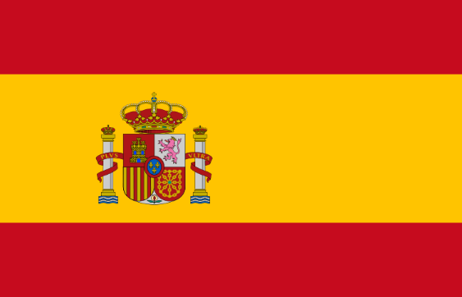
COUNTRY: SPAIN
COMMITTEE: WORLD HEALTH ORGANIZATION (WHO)
AGENDA: Improving Access to Immunisation and Halting the Spread of Vaccine preventable diseases.
Health is a state of complete physical, mental and social well-being and not merely the absence of disease or infirmity. The number of cases of COVID-19 has increased rapidly in several countries. At that time, it was recognized that
“COVID-19 Pandemic is not a word to use carelessly. It is a word that, if misused, can cause unreasonable fear, or unjustified acceptance that the fight is over, leading to unnecessary suffering and death”
According to the World Health Organization (WHO) vaccination is harmless that can induce protective immunity against the corresponding infectious agent. In practice, the terms “vaccination” and “immunization” are often used interchangeably. Vaccination is a highly effective method of preventing certain infectious diseases and is generally very safe.
As a delegate of Spain, I’m proud to be representing my country “Kingdom of Spain”. Spain is the third largest country in Western Europe. According to the World Economic Forum and to Bloomberg, Spain has the most efficient health system in Europe. Spain was affected severely by COVID-19. The national wide lockdown that began March 15, 2020 brought daily life to halt. People started to vaccinate. Public gathering were cancelled. Some local shops were allowed to open, by appointment. Restaurants were allowed to open for takeaway meal services. Borders remain closed, and no travel between provinces permitted. Face masks “highly recommended” on public transport and outside the home. Those who test positive are required to self-isolate until three days after the fever has broken and a minimum of seven days after the beginning of symptoms. Serious cases are sent to hospital. The Corona virus incidence rate in Spain has fallen to its lowest level since August 2020.

The COVID-19 vaccination drive is a key to Spain’s falling incidence rate. As of June more than 27 percent has been fully vaccinated, while 46.4 percent of population had received at least one dose of vaccine. Late January 2021, weekly COVID deaths in Spain have dropped by 90 percent. A boy born on the Spanish island of Ibiza has become the first newborn in Spain with COVID-19 antibodies, after his mother received the vaccine in the third trimester of her pregnancy, according to local media reports. The Government of Spain is introducing new exemptions from co-payments for outpatient prescriptions – a reform expected to benefit around 6 million people. From 1 January this year, low-income pensioners, moderately and severely disabled children, and households receiving child benefits no longer have to pay out of pocket for prescribed medicines. Financial supports were given to affected peoples. The WHO Barcelona Office for Health Systems Financing is working with a team of Spanish experts to assess the extent to which people living in Spain experience financial hardship when they use health services, including medicines.
Vaccination is the only safer way to build protection against COVID 19. There is lack of awareness among people about vaccination leads to pandemic. We need to create awareness about vaccination among people. So that in upcoming years we would experience disease free nation.
DELEGATE:
R LAVANYA DEVISHNI,
ADARSH VIDYA KENDRA.

