Position paper
Country : China
Delecate : S.M.Vebinesh kumar
VII A
Adarsh Vidya Kendra, Vetturnimadam.
Insert image of country :
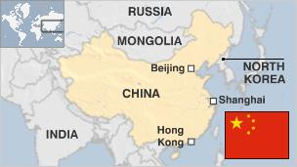
Summarise about the country:
- China is officially known as the People's Republic of China
- In China, rice is usually the staple food for people living in the south of China, while food made of wheat flour such as steamed bread, bread, and buns is the staple for people living in the north
- Mandarin language is spoken in China. The tonal nature of the language makes speaking it very hard as well. ... Mandarin Chinese (the most common dialect) has four tones, so one word can be pronounced four different ways, and each pronunciation has a different meaning.
- Currently, China's economy is estimated to be five times larger than India's.
- The six birds referred to the goose, pheasant, cuckoo, pigeon, quail and buttonquail. As for the six beasts, they were the milu (also known as Père's David deer), deer, bear, musk deer, wild boar and rabbit.
- Under the precepts of Chinese medicine, balance is key, and hot or warm water is considered essential to balance cold and humidity; in addition, it is believed to promote blood circulation and toxin release
- baiju is the most infamous drink in China
- The People's Republic of China was founded in 1949 after the Communist Party defeated the nationalist Kuomintang, who retreated to Taiwan, creating two rival Chinese states - the People's Republic on the mainland and the Republic of China based on Taiwan.
- As of September 2020, China is the most populated country in the world with over 1.4 billion people
- It is the most populated country in the world, with charming and captivating citizens. It is also one of the leading political and cultural forces that helped shape our world. China also has a rich and beautiful history, with people more concentrated on learning and inventing, rather than conquering
- many expats, especially women, find living in China is much safer than in cities like London or New York.
- The flag of China, officially the National Flag of the People's Republic of China and also often known as the Five-starred Red Flag,
- The five major landforms—mountain, plateau, hill, plain, and basin—are all well represented. China's complex natural environment and rich natural resources are closely connected with the varied nature of its relief.
- In China, rice is usually the staple food for people living in the south of China, while food made of wheat flour such as steamed bread, bread, and buns is the staple for people living in the north
- The country is officially divided into 23 provinces, five autonomous regions, four direct-controlled municipalities (Beijing, Tianjin, Shanghai, and Chongqing), and two special administrative regions of Hong Kong and Macau.
- China is considered a “coconut culture”. Chinese people present a stony, formal exterior, but they are actually as warm and welcoming as other cultures. Close friendships and relationships in China are earned over time compared to Western countries.
- Family members living in one home is a reflection of Chinese success. Elders are highly revered in China. Younger generations are also expected to take care of their aging family members. They even have an Elderly Rights Law!
- Put all of China’s railway lines, it can loop around the earth two times!
- Chinese New Year’s celebration lasts for 15 days! It’s the biggest holiday in China which is usually celebrated in January or February. New year in China is even more popular than Christmas. But here’s an even interesting fact: many countries in the world celebrate Chinese New Year as well.
- In China, every year is named after one of the 12 Chinese zodiac animals: Rat, Ox, Tiger, Rabbit, Dragon, Snake, Horse, Goat, Monkey, Rooster, Dog, and Pig. 2020 is year of the Rat.
- The Bailong Elevator in Wulingyuan area of Zhangjiajie, China can carry visitors up to 300 meters high on a cliff’s edge. This elevator is the world’s heaviest and highest outdoor elevator.
- China is a multi-religious country. Because of its large population, many world religions have adhered there. However, most Chinese usually practice Taoism, Confucianism, and Buddhism.
- China, along with Italy, has the highest number of UNESCO sites in the world. Some of the most visited UNESCO sites in China include the: Forbidden City in Beijing, The Great Wall of China, Summer Palace in Beijing, and the Temple of Heaven in Beijing and the world-famous Terracotta Army.
- Speaking of UNESCO sites in China, the Forbidden City in Beijing has 9,000 rooms all in all. It is one of the largest and oldest imperial palaces in the world.
- Despite its huge size, China surprisingly only has one timezone. Everybody is using the official Beijing time.
- Every single Panda living in the whole world belongs to China. That means if you see a Panda in your country, it is lent by China. In China, all Pandas can be found in Chengdu, Sichuan’s capital city.
- Pandas eat all day long. They take about 10 to 16 hours a day eating. Despite belonging to the bear family, they do not hibernate.
- Chinese people are the biggest travel spenders in the world. They spend US $260 billion every year, twice the spending of American travelers.
- Ice cream was discovered in China some 4,000 years ago. The Chinese people back then combined milk, rice mixture and snow to create the yummy dessert.
- Ancient Chinese medicine already discovered blood 2,000 years before European scientist William Harvey announced it in 1628.
- Chinese people avoid using or mentioning the number “4” as it is associated with death.
- Nope, football (soccer) was not invented in Europe. The first recorded information about the sport was 2,200 years ago in China. Ancient Chinese people created the world’s first soccer ball made of leather. The ball was filled with feathers and hair and the sport was original called ‘Tsu’ Chu,’ which means ‘kicking ball.’
- China builds a new skyscraper every five days. There is no country in the world that is growing as fast as China. In a year, China builds at least 73 new skyscrapers.
- You will never eat the same food twice in China. Every region in the country has their own dishes, distinct flavours and cuisine. In addition, Chinese food is served almost always fresh.
- Chopsticks were originally used for cooking and not eating.
- Unlike brides across the world, Chinese brides wear red instead of white. Red is considered to be a lucky color in China.
- Fanjingshan mountain is one of China’s best kept secret I know, we said we would give you 30 interesting facts, but here is another one for free! Fanjingshan is in Guizhou province in south China.
Agenda:
Advancing responsible state behavior in cyberspace in the context of international security

Previous situation related to your agenda:
China houses the largest number of hackers on Earth. During the last quarter of 2012, the world's most populous country accounted for 41 percent of the world's hacking traffic.

Current situation:
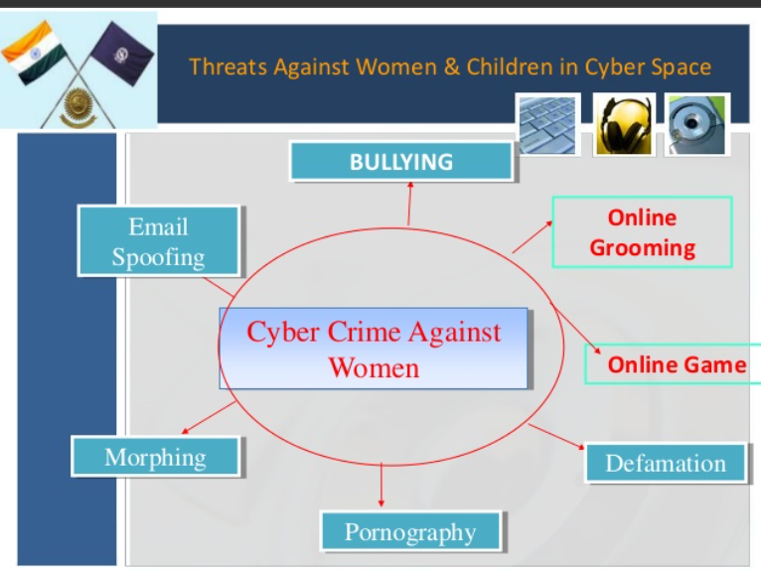

Problems solution:
- Reporting and Policing Internet Crimes in China
  - The primary national law enforcement agencies that investigate domestic crime on the Internet include the Ministry of Public Security (MPS) and the Ministry of Industry and Information Technology (MIIT) and Internet Society of China (ISC).

cyberspace

- The definition of cyberspace is the environment of the Internet. An example of cyberspace is the home of Google, Yahoo and Facebook.
- Cyberspace is a concept describing a widespread interconnected digital technology
- Cyberspace allows users to share information, interact, swap ideas, play games, engage in discussions or social forums, conduct business and create intuitive media, among many other activities. The term cyberspace was initially introduced by William Gibson in his 1984 book, Neuromancer.
- Cyberspace can be viewed as three layers (physical, logical, and social) made up of five components (geographic, physical network, logical network, cyber persona, and persona).
Cyberspace Advantage
- informational resources.
- Communication
- Entertainment
- opportunities.

