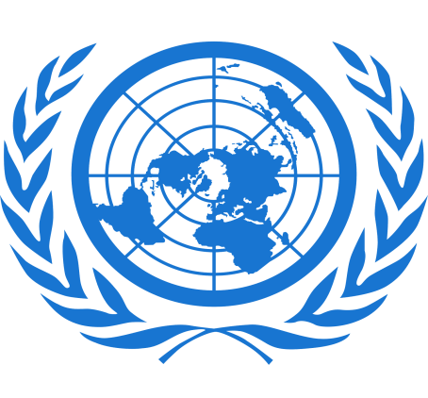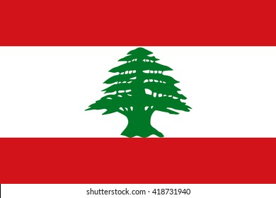
COUNTRY - LEBANON
COMMITTEE - UNITED NATION HIGH COMMISSION FOR REFUGEES
TOPIC AREA - POTENTIAL SOLUTION FOR THE PROBLEM OF THE REFUGEE CRISIS IN UKRAINE

Lebanon is home to roughly six million people and covers an area of 10,452 square kilometers (4,036 sq mi), making it the smallest country in continental Asia.
Head Of Government: Prime Minister: Najib Mikati
Capital: Beirut
Population: 6,685,000
Head Of State: President: Michel Aoun
Form Of Government: Unitary multiparty republic with one legislative house
GDP per capita: 4,891.00 USD
Russia-Ukraine conflict affected Lebanon's capacity to secure sufficient wheat, urging UN to increase food support for his country, a statement by Lebanon's Presidency reported. "Wheat warehouses were destroyed in the Beirut port blasts in 2020, and the war in Ukraine further impacted our access to this commodity," he was quoted as saying by Xinhua news agency. He remarks came during his meeting in Italy with David Beasley, the executive director of the World Food Programme, who said the WFP will continue supporting Lebanon despite the increasingly difficult global situation. He also met with the director-general of the Food and Agriculture Organization (FAO), who said that FAO will urge member states of the organization to double their production of basic food products with the aim of facing the emerging global situation in light of the war in Ukraine.
The Emergency Response Plan (ERP), launched in August 2021, aims to address the needs of the most vulnerable among the Lebanese, migrants, and Palestine refugees in Lebanon affected by the multiple crises. A revised appeal for the ERP was issued last week calling for $546 million to meet needs until the end of 2022. Refugess crisis can be solve through voluntary repatriation, through resettlement overseas and through integration either in the country of present residence or in combination with intra-European migration.Lebanon started a plan, Lebanon Crisis Response Plan (LCRP) aims to deliver critical assistance to more than three million people as vulnerabilities rise, and to support public infrastructure, services, and the local economy. 2.5M Syrians, Lebanese &Palestine refugees received support.

SUBMITTED BY – YUG SHARMA
CLASS – +1 COMMERCE

STUDENT OF GURU NANAK PUBLIC SCHOOL, DALHOUSIE

