Position paper
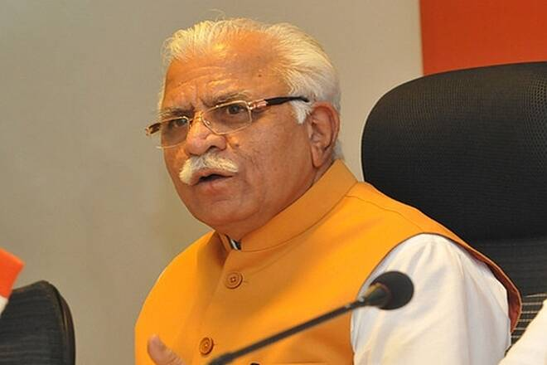
Name- manohor lal khatter
Committee-AIPPPM
Agenda – police brutality and strengthen our justice system
Date- 15/8/2020
Delegate- karan singh
Introduction to agenda
Monohar lal khatter the cm of Haryana came to this to address police brutality In India and to strengthen our justice system and want to find solution of this issue and to prove that we have worked on it and did same valuable changes
The main issues
First of all I will talk about my state Haryana so as my states show that Between January and June 2020, Haryana Police registered 49,978 cases under the Indian Penal Code (IPC) against 51,928 FIRs in the corresponding period of 2019, Manoj Yadava, director general of police (DGP) said, adding that the overall crime was reduced by 3.75%. the crime rate in Haryana decreased and I will talk about how many police force we have Haryana Police has a total strength of 56747 (Gazette Officers/352, Inspectors/779, Sub Inspectors/1836, Assistant Sub Inspectors/4581, Head Constables/9215, Constables/39984). In Haryana there are 22 Districts . and have the good amount of police force but in may riots our may policemen are killed but they are forced by politician let’s take a example of Delhi riots many people do not know what they were protesting they were funded by many politician and media do not show the the positive side of police they also show bad side or brutally side
We are proud that we improved the condition of our police force
Strengthen justice system
I would like to start with a quote
`Justice delayed justice denied`
I would like to state that that we worked upon the so many improvement our justice system and at the time of congress there were 43.576 cases pending in high court now the stae are changed and we made the changes the quality of workers
- We would appoint a top secret official who would be loyal towards the country and will tell all the mistakes which the officials are doing
- Increasing salary
- Give quality time and good surrounding

