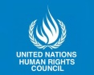
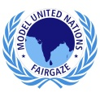
h
UNHRC
Position Paper
Indonesia

Committee: United Nations Human Rights Council
Agenda: Investigating the Existence of Chinese Concentration Camps for Uyghur Muslims
Delegation: Indonesia
Delegate Name: Simran Mishra
Overview
Uyghurs are a Turkish ethnic group originating from Central and East Asia. The Uyghurs are recognized as native to the Xinjiang Uyghur Autonomous Region in Northwest China. They are one of China's 55 officially recognized ethnic minorities. The Uyghurs are recognized by the Chinese government as a regional minority of Xinjiang. The Chinese government has committed a series of ongoing human rights abuses against Uyghurs that is often characterized as genocide.
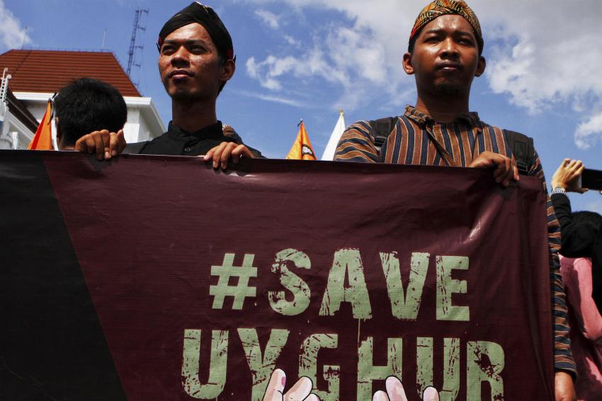
Since 2014, the Chinese government, under the administration of Chinese Communist Party (CCP) General Secretary Xi Jinping, has pursued policies that incarcerated more than an estimated one million Turkic Muslims in internment camps without any legal process. This is the largest-scale detention of ethnic and religious minorities since World War II. Experts estimate that, since 2017, some sixteen thousand mosques have been razed or damaged, and hundreds of thousands of children have been forcibly separated from their parents and sent to boarding schools. The massive re-education camps are a morally unacceptable counter-terrorism strategy, and the many reports of torture which are against international human rights laws are deeply concerning. Moreover, it is disgraceful that China is actively trying to hide its surveillance and continues to deny the existence of its camps.

Proof of existence of the concentration camps.
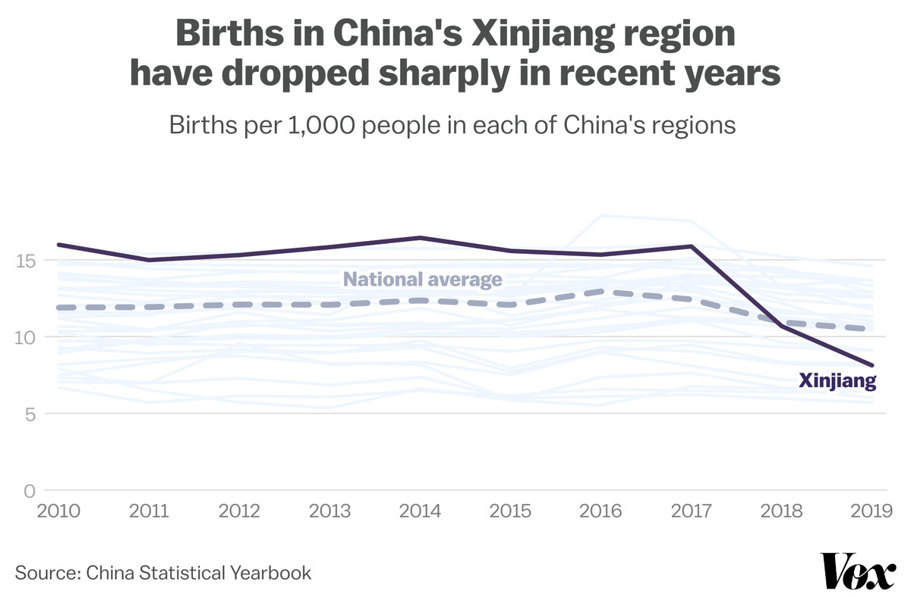
As the media is controlled by the government in China people are unable to access the information about Uyghur Muslim genocide in Xinjiang. Thus the only proofs about these concentration camps are the downfall in their birth rate, the women who have fled these camps and the security guard of the camp who spoke to BBC through a video link. China kept denying this for decades. After confronting China about these actions with proofs, the most populous nation responded saying that strict actions are being taken to prevent Islam terrorism.
Indonesia’s Stand
If human rights violations of this scale were taking place in Europe or the United States, one would expect Muslim-majority countries, including Indonesia, to have erupted in protest. But so far, there has been little to no response. All because these abuses are taking place in China.
Although, the Chinese government is trying to take our support by giving certain scholarships to Indonesian indigenous students, the Indonesian government is strictly against the concentration camps for the Uyghur Muslims in China.
There are numerous protests and revolts taking place in several cities of Indonesia like Jakarta and the government will definitely take steps to reduce the dissatisfaction and dissent of the citizens. Indonesia—which has played a positive role in the Rohingya refugee crisis—has shown its commitment to promoting rights elsewhere in the region. It should do no less for China’s Muslims.
Possible Solutions:-
- As China basically runs on international trade, we can prohibit trade with it for some time until it fulfils all the demands.
- The demands should include the release of all the detainees with rehabilitation services.
- If not so the Chinese government can hand them over to countries willing to give them citizenship.
- Surveys made by UN and its forces can always be an option to investigate further about such camps.

