POSITION PAPER
Committee: G20 Leaders Summit
Country: Kingdom of Saudi Arabia
Agenda: Promoting Solidarity, Equality, and Sustainability

About the Country
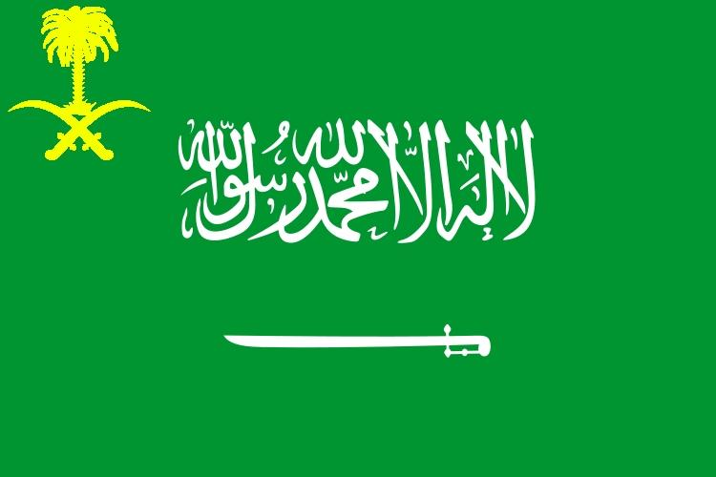
The Kingdom of Saudi Arabia is located in the Middle East, on the Arabian Peninsula, and is part of the continent of Asia. Covering approximately 2.15 million square kilometers, it is the largest country in the Middle East. Saudi Arabia has a population of around 36 million people and is known for its vast deserts, including the Rub’ al Khali, one of the largest sand deserts in the world. The country’s economy is primarily driven by oil, being the world’s largest oil exporter, but it is diversifying under Vision 2030 to include sectors such as tourism, renewable energy, and technology. Its geography features deserts, mountains, and a long coastline along the Red Sea and the Persian Gulf. Strategically located at the crossroads of Asia, Africa, and Europe, Saudi Arabia plays a key role in global trade and diplomacy.

Current Challenges Related to Agenda

Saudi Arabia faces challenges in achieving solidarity, equality, and sustainability. Despite economic growth, income inequality persists, with a significant wealth gap between urban and rural populations. Environmental issues include high carbon emissions due to oil dependence and severe water scarcity affecting agriculture. Social disparities, particularly in women’s workforce participation and youth opportunities, remain critical. According to the World Bank, Saudi Arabia’s Gini coefficient is 45, indicating moderate income inequality, and renewable energy currently contributes less than 1% of the total energy mix. Addressing these challenges is essential to align national development with sustainable global practices.

Country Policies on Agenda

- Solidarity

Saudi Arabia promotes social inclusion through programs empowering women and youth. Initiatives like the National Transformation Program provide equitable access to education, employment, and entrepreneurship. Social development projects improve healthcare, housing, and welfare for disadvantaged communities.

- Equality

Policies aim to reduce disparities by enhancing education, labor participation, and legal reforms for equal rights. Women now represent over 33% of the workforce due to reforms, reflecting progress toward gender equality. Vision 2030 prioritizes inclusive growth and equitable opportunities for all citizens.

- Sustainability

Saudi Arabia invests in renewable energy projects, such as solar and wind farms, targeting 50% energy from renewables by 2030. Environmental regulations promote water conservation, carbon emission reduction, and sustainable urban planning. The Saudi Green Initiative aims to plant 10 billion trees and reduce carbon emissions by 60% by 2030.

Common Goals of the Country

Saudi Arabia seeks a balance between economic growth, social equity, and environmental sustainability. The country envisions a society with equal opportunities for all citizens, a diversified economy not solely dependent on oil, and an environment safeguarded against climate change. Through domestic reforms, international partnerships, and sustainable development projects, Saudi Arabia aims to serve as a model for resilient governance, promoting solidarity, equality, and sustainability nationally and globally.

Globally Proposed Solutions

- Strengthen international collaboration for sustainable energy and climate initiatives.

- Promote global policies supporting social inclusion, women empowerment, and youth participation.

- Develop joint frameworks for equitable economic growth and technology transfer.

- Encourage G20 nations to fund and implement projects addressing income inequality and environmental challenges.

- Facilitate knowledge sharing and partnerships to achieve global sustainability goals efficiently.

Sources

Vision 2030 Official Website. (n.d.). Vision 2030. Retrieved December 5, 2025, from https://www.vision2030.gov.sa

Saudi Green Initiative. (n.d.). Saudi Green Initiative. Retrieved December 5, 2025, from https://www.saudigreeninitiative.org

National Transformation Program. (n.d.). Vision 2030 National Transformation Program. Retrieved December 5, 2025, from https://www.vision2030.gov.sa/v2030/ntp/

World Bank. (n.d.). Saudi Arabia Data. Retrieved December 5, 2025, from https://data.worldbank.org/country/saudi-arabia

