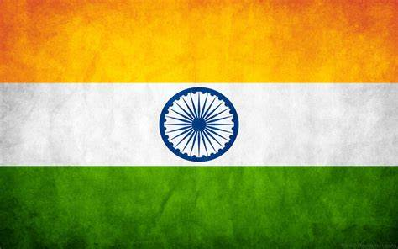
COUNTRY: INDIA
AGENDA: War situations between China and India, along with the consequences if the war breaks out.
COMMITTEE: United Nations Security Council (UNSC)
Our country has full faith in the leadership of our P.M Hon’ble Shri Narendra Modi in leading India’s capabilities to tackle this war situation between India and China.
Our Prime Minister has clearly stated ‘India wants peace, but if provoked, India will provide an appreciate response. And in the case of our departed martyred brave soldiers the country should be proud that they died fighting them. Whenever we have had differences, we have always tried that difference does not become a dispute. We never provoke anyone but we don’t compromise with the integrity and sovereignty of our country. Our P.M. wants to assure the nation that the sacrifice of our soldiers will not go to waste. For the people of India, the integrity of India and sovereignty is at the top and nobody can stop us from protecting them. Nobody should have an illusion or doubt in this matter.’
Tensions between India and China are not new. The two countries—which share the world’s longest unmarked border—fought a full-fledged war in 1962 and have since engaged in several small skirmishes. Not since 1975 has a bullet been fired across their shared border. As a result, the theory that Sino-Indian clashes are flashes in the pan and unlikely to lead to more extensive fighting has become a widely held consensus. Recent events, however, suggest that escalations are highly possible. Both sides have substantial—and growing—military deployments along a mostly disputed border. And for more than a decade, the People’s Liberation Army (PLA) has been testing India’s military readiness and political resolve along several strategic areas. Peace can no longer be taken for granted.
At least 20 people have died in clashes between Indian and Chinese troops along the disputed Himalayan border running along the Ladakh area of Kashmir. It is the first fatal clash since 1975 and the most serious since 1967. This tensions have been escalating since late April, when China sent thousands of troops into the disputed territory along the Line of Actual Control (LAC), bringing artillery and vehicles.
India and China fought a war in 1962 over their contested border in the Himalayas. The war ended with a truce and the formation of a de facto boundary, known as the Line of Actual Control.
There has been an uneasy and fragile peace since, punctuated by skirmishes on the border, including in 2013 and 2017.
No official border has ever been negotiated, the region where the clashes occurred is hostile terrain, at high altitude and sparsely populated, running through the Ladakh region bordering Tibet, home to a Buddhist-majority population. It is a popular tourist destination.
China claims more than 90,000sq km in the eastern Himalayas and another 38,000sq km in the west, both of which are disputed by India.
India is a country which will give a way better revert back to China but yes if the situation will be under control, we will be dealing it in peace as our country does not want war and wants to maintain peace and humanity…….

