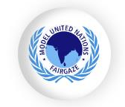
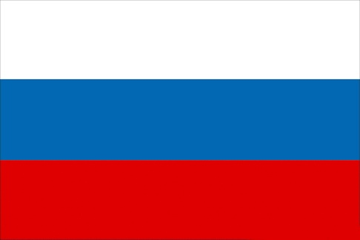
Russia

Committee – United Nations General Assembly (UNGA)
Agenda - Discussing How Climate Change Will Further Threaten International Peace and Security
Delegate - Adya Srivastava

Climate change is one of the most pervasive global threats to peace and security in the 21st century. But how many people would list this as a key factor in international relations and domestic welfare? In reality, climate change touches all areas of security, peace building, and development. The impacts of climate change are already adversely affecting vulnerable communities, as well as stretching the capacities of societies and governments.

At present, the average annual temperature in the western regions of Russia rises by 0.4 – 0.5 °C every decade. This is due to both an increase in the number of warm days, and also a decrease in the number of cold days, since the 1970s. The occurrence of extremely hot days in the summer season has increased over the past 50 years, and the number of summer seasons with extremely hot days between 1980 and 2012 has doubled compared to the preceding three decades.
Over the last 100 years, the warming in Russia has been around 1.29 degrees Celsius, while warming on the global scale has been a, 0.74 degrees, according to the IPCC Fourth Assessment Report, showing that the warming of the Russian climate is happening at a faster rate than average. In the Arctic, for example, temperatures are rising at double the rate of the global average, degrees per decade over the past 30 years. The annual surface air temperature maxima and minima both increased, and the number of days with frost decreased over the last 100 years. The warming has been most evident in the winter and spring periods, and is more intense in the eastern part of the country, according to the Inter-Agency Commission of the Russian Federation on Climate Change, 2002. As a consequence, a lengthening of the vegetation period is seen across much of Russia, with the earlier onset of spring, and later beginning of autumn.

Russia pervious actions includes Paris Agreement: In 2015, Russia joined the Paris Agreement, an international treaty within the United Nations Framework Convention on Climate Change (UNFCCC). By joining the agreement, Russia committed to taking actions to limit global warming to well below 2 degrees Celsius above pre-industrial levels and pursue efforts to limit the temperature increase to 1.5 degrees Celsius. Internationally there was an Intergovernmental Panel on Climate Change (IPCC): The IPCC is a scientific body established by the United Nations to provide policymakers with regular assessments of the scientific basis of climate change, its impacts, and potential adaptation and mitigation strategies.

Every person needs to contribute equally to help prevent global warming. Similarly, we must identify the causes that are contributing to this dangerous phenomenon and work hard to find solutions. Furthermore, we must immediately put a halt to all those activities which are causing global warming. Follow the 3R’s, and spread awareness. Remember that even small steps can help you achieve the greatest goals.

