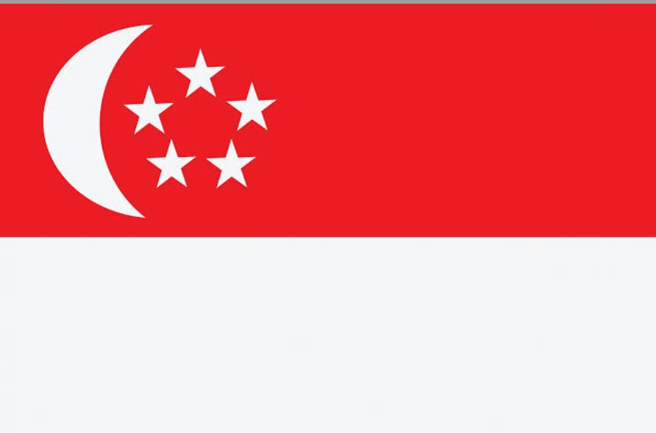
DWEPSE GLENGAZE
"MODEL UNITED NATIONS"

POSITION PAPER

"EACH ONE OF US MATTERS, HAS A ROLE TO PLAY, AND MAKE A DIFFERENCE. EACH ONE OF US MUST TAKE RESPONSIBILITY FIR OUR OWN KIVES, AND ABOVE ALL, SHOW RESPECT AND LOVE FOR LIVING THINGS AROUND US, ESPECIALLY EACH OTHER."

COUNTRY: SINGAPORE
COMMITEE: UNEA
AGENDA: ENSURING SUSTAINABLE CONSUMPTION
AND PRODUCTION
POPULATION: 58 LAKHS
DELEGATE: SAGNIK MUKHERJEE

INTRODUCTION: The Sustainable Development Goals (SDGs) are a set of goals under the 2030 Agenda for Sustainable Development (2030 Agenda), which is a global development framework adopted by World Leaders at the UN Sustainable Development Summit in September 2015. It comprises 17 SDGs with 169 targets and there are currently 247 indicators used to measure progress towards reaching the targets.

1.END POVERTY: The government provides financial aid to any family making less than $1,900 a month. The government alos povides aid in other forms such as making education more affordable, tax exemptions for impoverishes families and more affordable housing.

2.ZERO HUNGER: The goal of "Zero hunger" in 2 in eradicate food insecurity, providing sufficient and nutritious food to the population especially the most vulnerable, all year round. The organisation one Singapore is echoing this goal through foodbank programs working to eradicate hunger.

3.GOOD HEALTH AND WELL-BEING: Singapore recoginses that the social and healthcare needs of the elderly are closely related to and have an impact on their well-being. To coordinate the delivery of such services, the Agency for Integrated Care (AIC) helps senoirs access eldercare services and works with the elder care sector to expand and import services.

4.QUALITY EDUCATION: Singapore's policy makers decided early on to invest in the human resource and to dream, design and deliver a solid education to every child. Good teachers and effective school leaders from the cornerstone of that system. Singapore has developed a comprehensive system for selecting, training, compensating and developing teachers and principals.

5.GENDER EQUALITY: Singapore’s delegation to the Committee on the Elimination of Discrimination against Women asserted today that gender equality was central to the country’s burgeoning socio-economic growth and responded to the Committee’s concerns over trafficking in persons, reservations to the women’s Convention, reinforced stereotypes and other issues, as it presented its latest periodic report.

6.CLEAN WATER AND SANITATION: Singapore have come a long way in achieving uniserval access to afforable and high quality water as well as modern and accessible sanitation for all. There approach to water management is guided by three key strategies: (I) maximising the yields by collecting every drop of rain that flows on Singapore; (II) making water an endlessly reusable resource by recycling and reusing wastewater; and (III) turning seawater into drinking water through desalination.

7. AFFORDABLE AND CLEAN ENERGY: Singapore is exploring ways to increase the number of space available for development of solar PV panels. A one mwp floating solar PV system test-bed was launched at Tengen reservoir in the western part of Singapore in October 2016. Potentially, the energy generated could power about 12504 room flat. Singapore is also conducting environmental studies and consulting envionmental groups to study the possible impact of large scale solar PV Systems on natural habitats.

8.DECENT WORK AND ECONOMIC GROWTH: Singapore embarked on a major restructuring of in their economy in 2010, with good progress since. It invloved improving the skills of our workforce, growing an innovative economy and building a distinctive global city. Through the productivity performance had been weak in the domestically-orieneted sectors, overall real productivity grew by 2.5% p.a between 2009 and 2016. In 2015, they set up a Commitee on the Future Economy (CEF). Its objective was to adopt a forward-looking posture in order to develop economic strategies to position Singapore.

9. INDUSTRY, INNOVATION AND INFRASTUTE: Singapore recognise the importance of building good transport INFRASTUTE to facilitate the flow of people, goods, servies and ideas. Good transport connectivity rasies the quality of life and creates good jobs for Singapore. Singapore is home to one of the world's busiest container ports, and also has one of the world's best airport which serves more than 62 million passengers per anum. Singapore aims to improve access to unfo-communucations technologies and improve it's citizens quality of life. For this, the Singapore Government had introduced a fourth telecommunications provider through a New Entrant Spectrum Action and also allows moblie virtual network operators to provide servies. Through this they'll keep telecommunications and internet servies affordable.

10. REDUCED INEQUALITIES: Singapore has made some progress in tackling inequality. Over the last five years, the income growth at 20th percentile of full-time employee residents was 1.2% per annum in real terms. These results are encouraging and they are committed for continuing their efforts in this area. They can also apply for the Community Health Assist Scheme (CHAS), and recive subsidies for treatment at participating general practitioner (GP) and dental clinics. They have also introduced structural premium subsides for lower-to middle-incomr Singaporean s, as well as Additional Premium Support for those who are unable to afford their premiums even after subsides.

11.SUSTAINABLE CITIES AND COMMUNITIES: New approached to district-planning include integrating utilites, facilities and services at the district level instead of at a building level, such as district level instead of at a building level, such as district cooling systems and common tunnels. This allows to achieve economics of scale and cost savings. Another eg is Hawker centers that offer a variety of high and afforable food.

12. RESPONSIBLE CONSUMPTION AND PRODUCTION: Singapore takes steps to reduce plastics and packaging waste.Hawker centres are open-air food centres in Singapore where people from all walks of life can enjoy affordable food in a clean environment. Through this the food waste recycling rate from 12% has increased to 16% in 2017. Singapore has developed various online 3R guidebooks for businesses to encourage implementation of 3R practices. Singapore has also Map to improve productivity, promote growth and create better jobs for the cleaning and waste management sectors in Singapore. Singapore controls the import export transport, sale,storage and use of hazardous substances under the Environmental Protection and Management Act (EPMA)

13. CLIMATE ACTION: Singapore is amongst the 15 best-
performing countries in terms of emissions intensity from 2000 to 2012. There key mitigation strategies are outlined in our Climate Action Plan: (i) improving energy efficiency; (ii) reducing carbon emissions from power generation; (iii) developing and deploying cutting-edge low-carbon technologies; and (iv) encouraging collective action among government agencies, individuals, businesses, and the community. To facilitate applied research work, the National University of Singapore and Nanyang Technological University have set up several research institutes and centres, including The Singapore-Delft Water Alliance, Tropical Marine Science Institute, Earth Observatory of Singapore, Institute of Catastrophe Risk Management, Maritime Research Centre and NTU-JTC Industrial Infrastructure Innovation Centre.These events include the Singapore World Water Day, Singapore International Water Week, CleanEnviro Summit Singapore, Partners for the Environment forum, Clean & Green Carnival and Climate Action Carnival taking place throughout 2018 in Singapore.The exhibits of the gallery cover various environmental and sustainability topics such as climate, water, energy and waste.

14. LIFE BELOW WATER: To satisfy these competing demands, we have to take a pragmatic approach in balancing different users’ requirements. As such, Singapore approaches marine biodiversity conservation through their unique Integrated Urban Coastal Management approach. Singapore adapted the Partnership in Environment Management for the Seas of East Asia (PEMSEA) integrated coastal management principles to their unique contacts by incorporating and urban perspective into the framework. Singapore also put in place strategies to litres oil and chemical spills in their marine environment.

15.LIFE ON LAND: The Tree Planting Campaign aims to plant a minimum of 10,000 saplings each year. Since 1971, Singapore have launched an annual Tree Planting Day on the first Sunday of November to plant trees and shrubs in public places like housing estates, parks and schools.Singapore is one of the most densely populated countries in the world, with a population density of 7,796 persons per square kilometre.The Singapore Red Data Book is a publication by the Nature Society (Singapore) on endangered plants and animals in Singapore.The Sungei Buloh Wetland Reserve comprises 202 hectares of wetlands with an extensive mangrove forest in the northwestern part of Singapore. Chek Jawa is a unique natural wetland area where six major habitats meet and mix; it is located on Pulau Ubin, an island off the northeastern coast of Singapore.

16. PEACE, JUSTICE AND STRONG INSTITUTIONS:Singapore’s laws do not discriminate on the basis of gender or age. But they have taken additional measures to protest the most vulnerable segments of society.The Children’s and Young Persons Act (CYPA) safeguards the care, protection and rehabilitation of children and young persons below 16 years of age. The Singapore Police Force surveyed 4,800 Singaporeans and Permanent Residents in 2017.

17. PARTNERSHIPS FOR THE GOAL: The Singapore Cooperation Programme (SCP) is their flagship technical assistance programme.In support of the 2030 Agenda, Singapore launched the Sustainable Development Programme (SDP) under the SCP in 2015. The SDP aims to support our fellow developing countries’ achievement of the SDGs by building capacity at three levels – leadership, city, and community – through partnerships with UN agencies and local NGOs. Under Singapore’s Chairmanship, the ASEAN Leaders’ Vision Statement endorsed by the 32nd ASEAN Summit in April 2018 calls for ASEAN to become a sustainable community which promotes economic and social development alongside environmental protection, while leaving no one behind.

"THE GREATEST THREAT TO OUR PLANET IS THE BELIEF THAT SOMEONE ELSE WILL SAVE IT."

