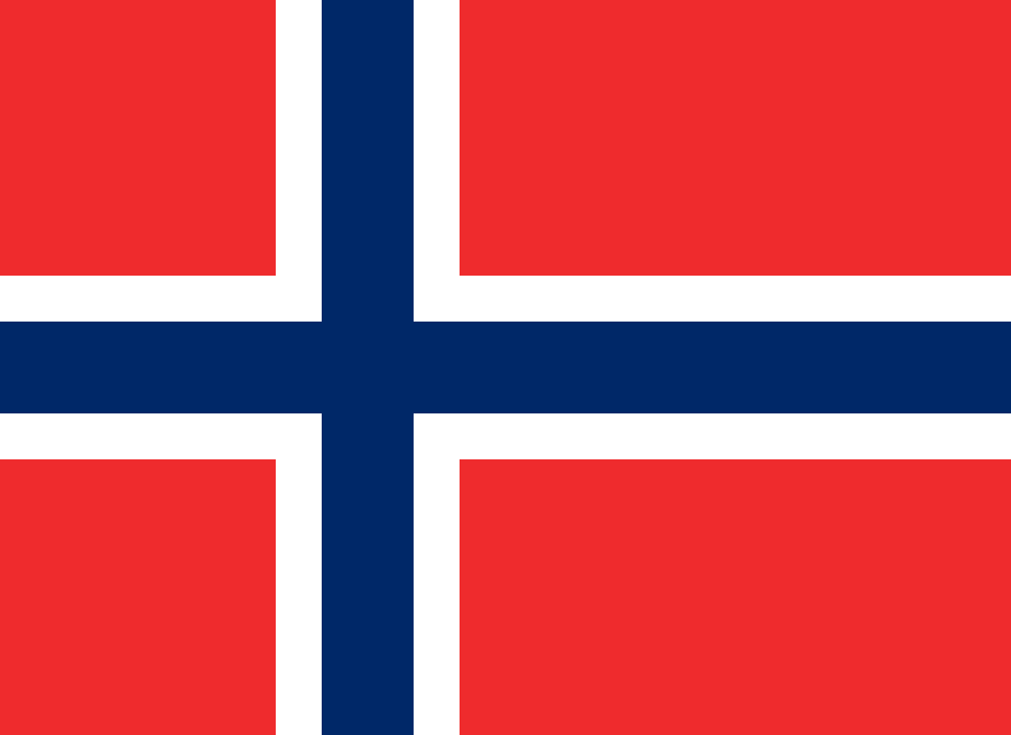
Norway
The Commission on the Status of Women

Topic: Protecting Women in Migration from Human Trafficking, Sexual Slavery and Sexual Exploitation

The Delegate of Norway would like to clarify its stances on the situation Protecting women in migration from human trafficking, sexual slavery and sexual exploitation.

Every 10 minutes, somewhere in the world, an adolescent girl dies as a result of violence. Nearly one in five girls is sexually abused at least once in her life. The media contributes harmful gender stereotypes that often trivialize violence against girls. Women and girls are repeatedly objectified and their bodies hypersexualized. Social media has "amplified age-old pressures for teenage girls to conform to certain sexualized narratives," according to a study published by The American Journal of Psychiatry. Consequences of hyper sexualization for girls and women include anxiety about appearance, feelings of shame, eating disorders, lower self-esteem and depression.

The condition in Norway, however, is considerably good. Norway ranks 2nd in the Global Gender Gap Report of 2020. There is slightest gender inequality in the country.

But, this doesn’t mean that there isn’t any sexual exploitation of women in Norway

Every single year many thousand women are taken from one country to another, often to Western Europe, as part of a trade in human beings.
Norway is taking part in international efforts to prevent and combat this serious form of crime and violation of human rights and play a proactive role in international efforts to develop norms and effectively implement them.
Because the fight against trafficking in women requires long-term commitment, Norwegian foreign and development co-operation policy will continue to be directed at the root causes of this trade.

The Action Plan comprises measure for:
■ protecting and helping women who are victims of human trafficking
■ preventing trafficking in women
■ detecting and prosecuting the traffickers
■ disseminating information and promoting co-operation that will fulfil the intentions of the plan

We have a special responsibility to protect and help the women in our country who are victims of human trafficking. We have a responsibility to prevent women from being recruited for such purposes, and to help curtail the demand that makes this such a profitable trade. And we have a responsibility to strengthen our legislation and give priority to the investigation of such crimes so that the organisers and other actors who profit from this activity are caught and prosecuted.

Submitted by-
Name: Aanya Sangar
Country: The United States Of America
Committee: The Commission on the Status of Women

