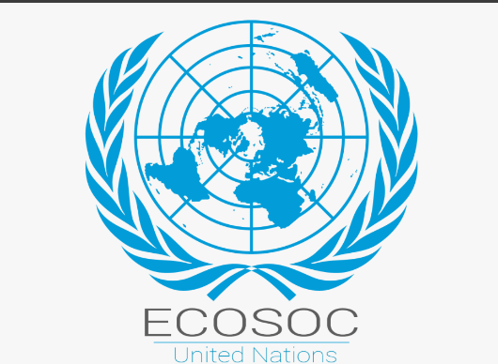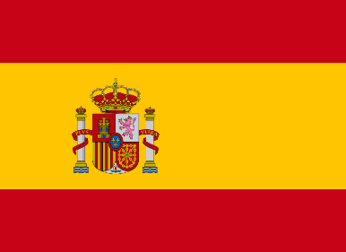**POSITION PAPER**

**PORTFOLIO:** Kingdom of Spain

**COMMITTEE:** ECOSOC

**AGENDA:** Empowering Youth Through Tech: Education and Employment in a Fragmented Global Economy

---------------------------------------------------------------------------

**I. Country’s POV, Background & Past Action**  
The Kingdom of Spain views youth digital empowerment as a linchpin for inclusive growth in today’s fragmented economy. The 2008 financial crisis and COVID-19 pandemic severely impacted Spanish youth, with unemployment peaking at 41.7% in 2020 (Eurostat). In response, Spain launched the Youth Employment Operational Programme, modernized its VET model, and implemented the National Youth Guarantee Strategy. Over €3.5 billion has been channelled into digital education and youth employability through the National Recovery and Resilience Plan. Spain’s Youth Institute (INJUVE) has advocated for skill accessibility, while programs like Digital Bootcamp and Campus Rural have equipped over 15,000 rural youth with in-demand skills.

Spain’s commitment to digital safety is reflected in its 2025 child online protection law, which mandates parental controls, restricts under-16 social media access, and addresses deepfake risks. Spain also leads EU discussions on age verification and youth digital rights.

**II. Treaties, Articles, Voting History, and Global Alignment**  
Spain’s policies reflect Article 26 of the UDHR and Article 13 of the ICESCR, aligning strongly with SDGs 4 and 8. As part of the EU, Spain supports the European Youth Strategy 2019–2027, the Digital Education Action Plan, and the Youth Employment Support (YES) initiative. It also backs UNESCO’s Global Skills Academy and has voted in favour of resolutions like A/RES/76/213 and A/RES/77/207 on youth employment and digital development.

Spain is committed to advancing digital rights through its Digital Rights Charter and AI Sandbox, addressing public concerns about data protection and inclusion. With the creation of AESIA and its Semiconductor Strategy, Spain is also leading AI governance in Europe. Through partnerships with Latin America and Sub-Saharan Africa under AECID and FONPRODE, Spain actively supports cross-border digital development and technical cooperation. Furthermore, Spain stands ready to share its digital governance models—such as the AI Sandbox and AESIA—with Member States seeking to build ethical, rights-based frameworks.

**III. Proposed Solutions – The REWIRE Agenda**  
Spain proposes the REWIRE Agenda—Resilient, Equitable Workforce through Innovation, Rights, and Education—to address the global youth tech divide through the following:

1. **UN Youth Digital Upskilling Network (Y-DUN):** A global mentorship and training fund for AI, cybersecurity, and digital literacy.
2. **Cross-Border Digital Mentorship Exchanges:** Pairing Spanish youth with peers from LDCs to enable two-way learning and skill-sharing.
3. **Global Framework for Recognizing Informal Digital Education:** Establishing a universal system to validate non-formal digital skills.
4. **Public AI Infrastructure for Education:** Promoting safe, multilingual AI classroom tools modelled after Spain’s AI Sandbox.
5. **Ethical Digital Citizenship Curriculum:** Embedding digital ethics, inclusion, and misinformation resistance into education systems.

Spain urges ECOSOC to support coordinated, rights-based digital transformation so that no youth is left behind—because empowerment must be a right, not a privilege.