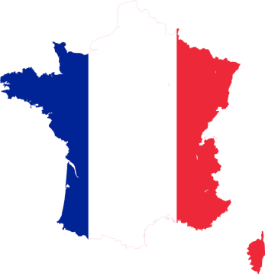FRANCE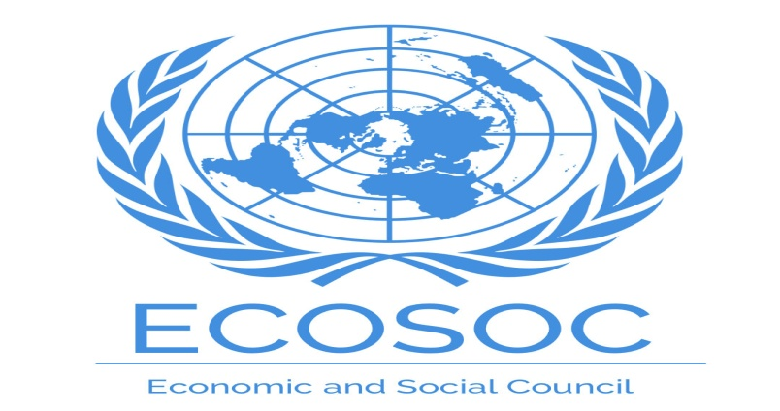

Community – United Nation Economy and Social Council

Agenda – Sustainable Development Goal (SDG 9)

Guru nanak Public School Dalhousie

- SDG 9 Support domestic technology development , research and innovation in developing countries including by ensuring a conducting policy for, inter alia, industrial diversification and value addition to commodities by 2030.
- France is considered a world leader in promoting sustainability last year , it ranked fourth overall in global sustainability.
France is the seventh largest economy in the world and the second largest in euro area
- Friend of the Earth France is an environment NGO created in 1970 since then NGO become one of the vital organization in the France ecological movement and it helped establish on of the largest grass rote environmental network Friends of the Earth international .Friend of the Earth France gather 30 autonomous local groups that work according to their priorities . The main activities of the NGO are focused on transition and ecology agriculture and food , economic justice , energy and resources and ricks and technology the organization activity work in both south and north part of France to achieve Sustainable. So cities committee to a achieving environment change at all levels by taking action through campaigns and mobilizing public participation .
- France has achieved seventh position in sustainable development . France implement the Paris climate agreement and promotes sustainable development . On 17 august 2015 well before COP 21 , the energy transition for green growth act voluntary commiemission by 40% below 199 level by 2030 .
- France participated in Rio De Janeiro agenda 21 . Rio De Janeiro agenda 21 is a non binding action plan of the United Nation with regard to sustainable development . It is product of Earth summit held in Rio De Janeiro Brazil in 1992 . The economy of France is highly development and market oriented . It is the world seventh largest economy by 2022 nominal figures .
- France step taking on sustainable development in next 10 year : France strongly supported the United Nation abortion is September 2015 of the 2030 Agenda for sustainable development goals for the world to reduce extreme poverty .
- Build resilient infrastructure prompt inclusive and sustainable industrialization and Foster innovation .

SUMITTED BY = HRIYANSHU SHARMA
FROM GURU NANAK PUBLIC SCHOOL
DALHOUSIE

