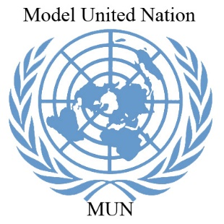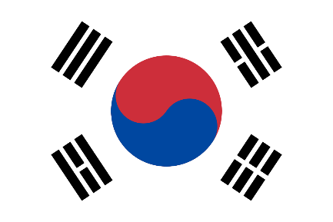
Position Paper
Committee- United Nations Security Council
Topic- Prevention of war between US and China in
context to the outbreak of corona virus
Country- South Korea

“South Korea is just one casualty of US-China ‘cold war’ ” – Moon- Jae
COVID-19 (Corona Virus Disease) pandemic, a name and virus which cause a great impact on world. The first corona positive case was detected in Wuhan, China on December 19, 2019 and the number changes to 7.41M, caused 418K deaths. No vaccine have been discovered till now of this dangeouroues virus. United States of America with 2.16M cases and 118K deaths is the most affected country. Wheras, epicentre of this virus, China is left with 210 cases.
South Korea, a country which fighted against this virus, the situation is better if compared to others. The first case was detected on 20 Jaunary of a 35 year old woman and the numbers shortly jumped to 12,155 total cases. The cases increased multi-fold on 21 February, the majority of them being reported in the city of Daegu. The increase was due to community spread, traced to a church in Shincheonji, alarming the Korean health. But now, only 1083 active cases are left in the country.
The trade market, global supply chains and the economies of country are decreasing and are going in a great loss. U.S.-China relations had sharply deteriorated long before the discovery of a mysterious virus in the Chinese city of Wuhan in late December. Powers like, US, South Korea, Brazil are claiming that this mysterious virus is invented in Chinese labs and dragons had not given proper details of the virus.
“US economy is the worst, it has ever been”- UN Chief
Economic Impact
The global economy could suffer between 5.8 trillion U.S. dollars and 8.8 trillion U.S. dollars in losses -- equivalent to 6.4 percent to 9.7 percent of global gross domestic product (GDP) -- as a result of COVID-19 pandemic, said a new report released by the Asian Development Bank (ADB).

South Korean president Moon said, the third supplementary budget of this year is on its way, as growth readings for Asia’s fourth-largest economy are likely to worsen in the second quarter. The coronavirus pandemic pushed South Korea’s economy in the first quarter into its biggest contraction since 2008, as self-isolation measures reduced consumption and global trade slumped. According to Moon- Jae, it is forecasted that South Korea's real GDP growth will be two percent in 2020, decreased by 0.3 percent compared to the forecast in November. The GDP is affected by the rapidly spread of the coronavirus (COVID-19) across the world.
1

While in US, the real GDP growth rate will decline 5 percent for each month of partial economic shutdown. The economic cost of the first two months spent fighting the pandemic will be $2.14 trillion (10 percent). Early estimates predicated that, the virus become a global pandemic, most major economies will lose at least 2.4 percent of the value their gross domestic product (GDP) over 2020, leading economists to already reduce their 2020 forecasts of global economic growth down from around 3.0 percent to 2.4 percent. To put this number in perspective, global GDP was estimated at around 86.6 trillion U.S. dollars in 2019 – meaning that just a 0.4 percent drop in economic growth amounts to almost 3.5 trillion U.S. dollars in lost economic output. US economy is also forecasted to come down by 2.8%. Mr. Trump’s US, is going in the biggest lost from 2003.
While in China, the economy is down by 0.4%. No special loss to any sector. As, the markets are reopening. Industries are reopening. Not in the whole country, the virus was spread in middle powers of China that is why, there is just a minor loss to the country.
“Among the top contributors to the country's gross domestic product, have begun to affect employment in the manufacturing sector”- Hong Nam- Ki
Unemployment and depression
South Korea recorded an unemployment rate of 4.5 % in May - it’s worst since January 2010. The number of South Koreans employed fell to 26.93 million in May, which is 392,000 less than in the same month of the previous year and represents the third consecutive month of year-on-year decline. Asia's fourth-largest economy has recorded three straight year-on-year declines in its unemployment rate since October 2009, during the height of the global financial crisis. The pace of job loss appears to have slowed after the loss of 467,000 jobs in April, the biggest monthly decline in 21 years. The South Korean government presented a third extraordinary budget, valued at a record 35.3 trillion won (around $29.59 billion), to combat the blow dealt by COVID-19 and to cushion its impact on key industries.
The unemployment rate in the United States jumped from 10.3 per cent to 14.7 per cent in the month of April, in the largest over-the-month increase since 1948. The unemployment rate of 14.7 per cent is the highest seen since the Great Depression. In April, the unemployment rate increased by 10.3 percentage points to 14.7 per cent. This was the highest rate and the largest over-the-month increase in the history of the series. Because of this pandemic, the US lost over 20 million jobs in April. This took its unemployment rate to nearly 15 per cent. Citizens of South Korea living in US are facing problems of unemployment. Nearly, 1.7M South Koreans are living in US from which, 0.34% are unemployed.
2
All sectors, are going down, no income and this results in depression. Not only because of virus, people are suiciding because of unemployment and low or no income. The rate of suicide in the country is increased by 1.2% per year, which was 3.27earlier, after the pandemic spread in whole country and unemployment increased.
“ ‘Corona virus’ or ‘Chinese virus’ ” – Donald Trump
Tourism
The COVID-19 outbreak has the most impact on the tourism industry. Amid lockdown across the globe, the sector has been the hardest hit by the outbreak. Since January 2020, almost every destination has put travel restrictions. And it is anticipated that the industry will be hit harder than the financial meltdown of 2008-2009.
The Korea Tourism Organization announced that nine planned festivals have been cancelled due to coronavirus situation in the country, while four have been postponed. Mostly, Chinese tourists contribute more than $11.5B to the Korean economy, according to Director of Academic Affairs, Kyle Ferrier as quoted by the Korea Economic Institute of America. South Korea travel advisory for citizens in most of the countries is currently not negative, but the increasing community transmission, if uncontrolled, could result in advises pouring in from rest of the world to avoid travelling to the Republic. Such development would have a material adverse impact on the Korean travel industry, especially aviation.
Tour cancellations and suspension of flights to China will cause a significant loss to the Korean economy, opined Ferrier. Inbound tourists to Korea are expected to witness a significant drop during 1 quarter of 2020 due to the coronavirus.
The U.S. travel and tourism industry generated over USD 1.6 trillion in economic output in 2017, supporting 7.8 million U.S. jobs. Travel and tourism exports accounted for 11% of all U.S. exports and nearly a third (32%) of all U.S. services exports. The sector represents ~ 2.5% of the country’s GDP. Immediate measures for short term, medium term and long term are required to support the industry and its stakeholders.
China accounted for the third-highest volume of overseas visitors to the US in 2018 after the UK and Japan, according to the US Travel Association. Chinese tourists spent approximately $34.6bn in 2018 during their visit to the US. The data also indicates that the trade deficit between the two countries would be 7.2% higher without the inbound travel from China. Inbound travel from China declined by 2.2% during the first six months of 2019 due to the US-China trade war and is forecast to further decline in 2020 due to the coronavirus outbreak.
The losses to tourism are expected to extend through 2024, since China is the single largest export market for the US, adds the company. The US tourism industry is projected to lose $10.3bn cumulatively in Chinese spending due to coronavirus, half of it being in 2020, according to estimates by Tourism Economics, an Oxford Economics Company. The number of visitors to US from Mainland China alone will drop by 1.6 million, while those from the rest of Asia will add-up to the losses.
3
“Will the virus ends or the world ends”- Park- Neuong Hoo
Conclusion
After the first cases appeared, the South Korean government ramped up testing at a speed almost unimaginable in the United States. Its swift response slowed the spread of the virus and saved thousands of lives. As of April 8, South Korea had suffered 200 deaths due to the virus (4 per 1 million of population) and the number of new cases has slowed, while the United States had suffered 13,000 deaths (39 per 1 million population) with new cases continuing to grow quickly.
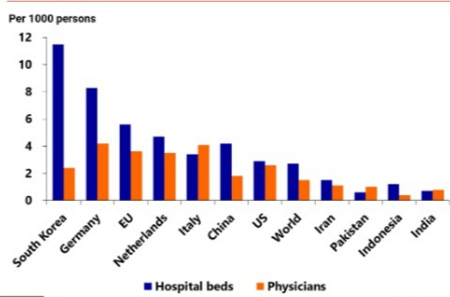
According to the graph, the best health situation is South Korea, while US is behind in the race, that is why, the number of corona positive are increasing day by day in thousands. For that, South Korea is providing masks and sanitizers to the country after successfully fighting by the virus. Beds and physicians are also sent to US for help. Testing kits and PPE kits are also provided to US for increase in number of testing and every case should be detected.
Earlier help by US to South Korea, results in a return by South Korea. US armies are set to stay in country, after agreement between both. Seoul wants the troops to stay because US forces in South Korea play the role of a mediator in military confrontations between neighboring superpowers such as China and Japan, another presidential official told reporters on condition of anonymity earlier on Wednesday.
The United States currently has around 28,500 troops stationed in South Korea, which North Korea has long demanded be removed as one of the conditions for giving up its nuclear and missile programmes. US troops have been stationed in South Korea since the Korean War, which ended in 1953 in an armistice that left the two Koreas technically still at war. Both countries are against of terrorism and North Korea. North Korean inventions of nuclear, atomic weapons, creating violence and making terrorist all the qualities are against peace and a majority of countries (74%) are against it.
As countries are claiming that China is responsible for this dangerous virus, US, Russia, Brazil and South Korea needs a proper investigation on the situation. World Health Organization is not responding on the topic. US had already warned WHO for leaving the organization of UN, followed by Brail. Both the countries are highest money sender to WHO. But, the question in on China and its cleverness. South Korea is also claiming that China had already invented the vaccine of the virus and not answering. To increase its economy, the virus was spread in big powers like India, Japan, US, Brazil and Russia. So, there will be no competition of China in world market.
4
This is a major problem, which must be discussed as it the war of two biggest powers. This will not only affect my country, can also affect your country as well. This issue must be discussed in conference, because it is against peace.
_____________________________________________________________________________
Source:
5
The Atlantics
The Soviet
World Health Organization
The Hindu

