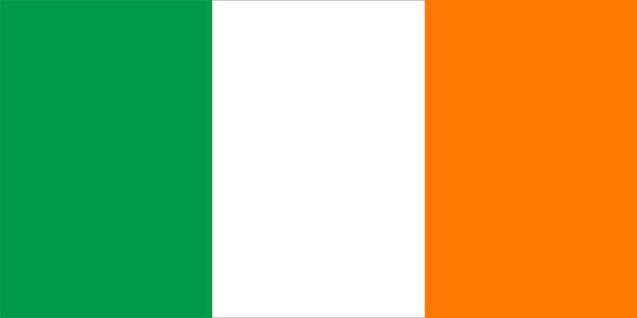
Portfolio – Ireland
Committee - UNHRC
Agenda - Deliberation on rights of LGBTQIA+ community
with special emphasis on the spreading of homophobic beliefs.

“Every part of you matters.
The world is better
when you are your authentic self— bold, beautiful, radiant—on full display.”

The delegation of Ireland strongly believes that expressing yourself is a basic human right and the LGBTQIA+ community deserves to have them. Ireland, from years has been working upon the betterment of the LGBTQIA+ community, through various policies or government campaigns; whether it was being the first country to legalize gay marriage with 62% of the Irish Republic’s electorate vote in favour of gay marriage. The huge vote marks yet another milestone in Ireland’s journey towards a more liberal, secular society. Yet, the condition all over the world is not similar, whether it’s the decriminalization of same sex marriage or discrimination of the members of the LGBTQIA+ community at several levels. According to a survey conducted by the Center for American Progress, in conjunction with the independent and nonpartisan research group NORC at the University of Chicago, included interviews with 1,828 self-identified LGBTQI+ adults and 1,542 self-identified non-LGBTQI+ adults ages 18 and older; half of LGBTQI+ adults reported experiencing some form of workplace discrimination or harassment in the past year because of their sexual orientation, gender identity, or intersex status.

Ireland has faced many hindrances on the path of achieving and building a safe and equal atmosphere for everyone. In Ireland, the 1861 Offences Against the Person Act and the 1885 Criminal Law Amendment Act criminalized sexual activity between men, regardless of whether it was consensual or not until 1993. Sexual activity between women was not legally outlawed but was also completely unacceptable across society, religion, and politics. It would take a long legal battle, taken by David Norris to the European Court of Human Rights and the activism of many LGBTQIA+ individuals throughout Ireland, before sexual activity between men was decriminalized in June 1993. Throughout the history, LGBTQIA+ people have faced discrimination because their gender or sexual identity was different from that of straight or cis people. The legislative rights and freedoms that LGBTQIA+ people in Ireland have now is due to the tireless activism, resistance, organizing and suffering that the past generation faced. Although in many ways LGBTQIA+ people now have many of the same rights that straight or cis people do, and Ireland is working towards building a more equal society.
With the overcoming of countless hindrances, Ireland is now one of the most liberal country all across the globe with Leo Varadkar’s election for the Taoiseach (Prime Minister), making him the youngest and first openly gay leader of Ireland. But for the world to be more equal for the LGBTQIA+ community, there are number of steps that should be taken in order to achieve peace and harmony amongst citizens. The first step should be spreading awareness among the citizens of the country and organizing government campaigns along with legalizing same sex marriage to ensure a gay friendly environment. Several laws should be issued to demolish hatred towards the LGBTQIA+ community in any form. There should be an effort made to reduce the pay gap and end workplace discrimination.

Two steps forward, one step back is still one step forward and that step is capable enough to tear down the deep roots of discrimination and guarantee in building a happier and more peaceful environment for everyone.

