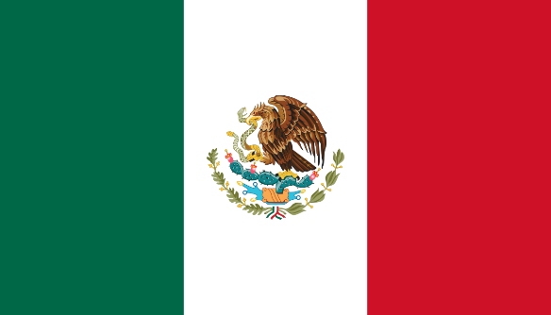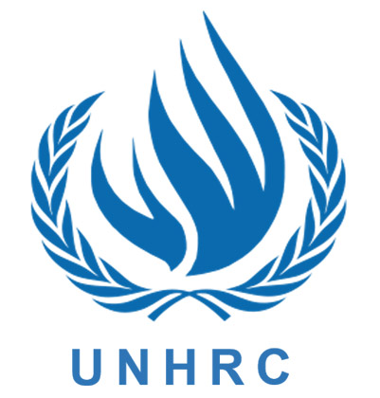

Committee: UNHRC
Author: United Mexican States
Topic: “Dealing with problems faced by refugees, asylum seekers and migrants with special emphasis on their rights during conflicts”
A quarter billion individuals worldwide live beyond their country of nationality. One-tenth of them, are refugees, asylum or migrants. Although each maintains a different story, they all have one thing in common - courage, the courage not only to survive but to endure and reconstruct their shattered lives. The plight of refugees is a common concern of mankind. The refugee situation has grown in size, scope, and complexity, and they require protection, assistance, and solutions. Millions of refugees, asylum or migrants live in protracted conditions, often in low- and middle-income countries facing their own economic and developmental challenges, and the average length of stay continues to rise. Despite the enormous generosity of host countries and donors, including an unprecedented level of humanitarian budget, the gap between needs and humanitarian funding has also widened. Mexico believes there is an urgent need for a more equitable distribution of the burden and responsibility for receiving and supporting refugees from all over the world, taking into account existing contributions and differences in capacities and resources between countries.
Mexico promotes the integration of asylum seekers and refugees in national systems, with full access to employment, public health services, and education at all levels. According to the UNHCR Annual Statistical Report, by 31 December 2021, there were over 73,500 recognized refugees and nearly 157,200 asylum-seekers in Mexico. Mexico is one of seven countries participating in the Comprehensive Regional Protection and Solutions Framework (MIRPS in Spanish) since the initiative was adopted in October 2017 as a regional contribution to the Global Compact on Refugees. Mexico’s National Action Plan for MIRPS has been key in promoting the protection and successful integration of asylum-seekers and refugees in Mexico. COMAR, which is part of the Ministry of Interior, is responsible for the asylum procedure and promotes collaboration between different institutions through interinstitutional roundtables and specialized committees. These also include international organizations and civil society. These mechanisms were strengthened from 2018 onwards as a follow-up measure to the national MIRPS commitments. Protecting and caring for refugees saves the lives of those involved and is an investment for the future, but, importantly, it must be accompanied by dedicated efforts to address the root causes. Climate, environmental degradation, and natural disasters are not in themselves the causes of refugee movements, but they increasingly interact with the drivers of such movements. First of all, addressing the root causes is the responsibility of the countries of origin of refugee flows. However, the prevention and resolution of major refugee situations are also of great concern to the international community as a whole, requiring urgent efforts to address their driving forces and triggers, as well as improved cooperation between political, humanitarian, development, and peace actors.
Each day, families hope to cross the border from Mexico in search of safety, and the International Rescue Committee is supporting programs in Mexican border towns to respond, and also to protect families from COVID-19. In conclusion, the ongoing war refugees need their rights, and treatment by the government should be human, refugees should not be treated as passive recipients of humanitarian aid and charity – they should be permitted to work, on basic needs in terms of access to basic services and assistance in health, nutrition, food, shelter, energy, education, as well as domestic items and specialized services for people with specific needs should be provided.
------------------------------------------------------------------------------------

