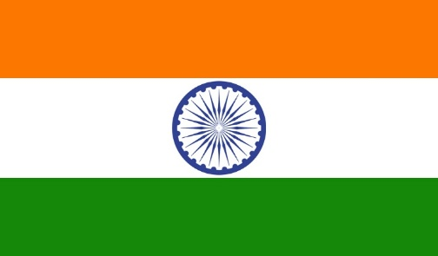
Country : India
Name of the delegate :Harini . J .Nair. R, Adarsh Vidya kendra
Committee : UNESCO
Agenda :
Harnessing emerging technologies for the achievement of sustainable development goal.

India is a large multicultural country in South Asia. India has grown significantly, in terms of both population and strategic importance, in the last 20 years India is famed for it’s train system , Also India is known all over the world for its Colorful and bright festivals such as Holi and Diwali.
India’s share of contribution is 0.534 percent of the total budget of UNESCO . Government of Indian had contributed Rupees 944.80 lakhs during 2012.In 2013 contribution has been enhanced to 0.666 percent .
India has played a leadership role in supporting the implementation of the priorities of UNESCO in its different agendas relating to education, science and culture. India is currently a member of 19 of its UNESCO ‘s conventions, including those on natural and cultural heritage, education, and intellectual property rights. UNESCO has two offices in India ,the New Delhi cluster office for eleven countries in South and Central Asia (Afghanistan ,Bangladesh, Bhutan, India, Iran, Maldives, Mongolia, Myanmar, Nepal, Pakistan, and Sri Lanka) and most recently the MGIEP-the Mahatma Gandhi Institute of Education for peace and Sustainable development.

India’s focus is to focus on a number of overarching objectives :
- Attaining quality education for all and lifelong learning.
- Mobilizing science knowledge and policy for sustainable development.
- Addressing emerging social and ethical challenges.
- Fostering cultural diversity, intercultural dialogue and a culture of peace.
- Building inclusive knowledge societies through information and communication.

Professor JS Rajput is India’s representative to the Executive Board (EXB) of UNESCO.
Now, India is enhancing an idea to improve the lives of the people by giving quality education to improve the educational skills of people in India .

Educational problems are expensive higher education which have turned out to be exorbitant in India. Neglect of Indian languages so that the children who are not knowledgeable in English, can’t contemplate science appropriately in English. There is a wonder word called ‘Brain Drain’. Because of this, we have lost so many talents that could be utilized in our nation for the betterment of education as well as overall development of the country.

The Best Solution for educational problems is we should not get addicted towards games (online) as well as not to use unnecessarily technology and to use it for our knowledge purpose. If we do this automatically children will gain their skills in education side and they get to know more about certain significant informations about their talents .This will get sustained too.

India has said this only for the children purposes and for the coming generation to get knowledge in overall.
From 18th century ,India has been working for children’s educational parts. And also India has promised that they will sustain educational development and has informed us to use technologies for our betterment in overall activities and to continue this forever.
Thank you .

