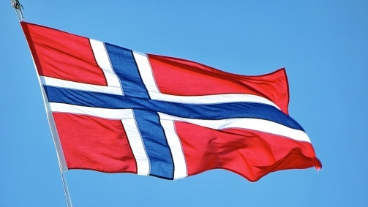

NORWAY

COUNTRY - NORWAY

ASSEMBLY-UNITED NATIONS HIGH COMMISION FOR REFUGES

AGENDA-POTATIENTIAL SOLUTIONS OF PROFFESION UKRAIN

NORWAY LIES ON NOTHERN EUROPE IN NORWAY THERE ARE VERY REFUGES COME FROM UKRAIN .IN THIS YEAR 2022 60,000 REFUGES COME FROM UKRAIN BUT NORWAY PRINCIPAL
SETTLE ONLY 35,000 . THE NORWAY PRINCIPAL WELCOMES ALL THE REFUGES AND NORWAY IS VERY DEVELOPMENT COUNTRY THAN OTHERS AND THEY GIVE ALL REFUGES ALL FACILITIES LIKE HOME , FOOD AND WORK ETC THE NORWAY ENTER REFUGES BECAUSE Immigration to Norway has increased significantly in the past few decades. There are two principal reasons for this: European economic migration and the increase in refugees seeking protection
GDP in Norway is expected to reach 440.00 USD Billion by the end of 2022, according to Trading Economics global macro models and analysts expectations. In the long-term, the Norway GDP is projected to trend around 440.00 USD Billion in 2023 15 reasons why living in Norway can be a wonderful adventure.
- Most people speak English. ...
- The scenery is beautiful. ...
- You can camp anywhere. ...
- A family-friendly state. ...
- Norway's banks have great online services. ...
- Health care is more or less free for everybody. ...
- Be part of a booming economy. ...
- Norway is not overcrowded
- THE SALARY FOR THE REFUGES SINGLE PERSON LIVING ALONE NOK 7,713 PER MONTH
- MARRIED COUPLE, 12102
- SINGLE PERSON 8,777
- Population of Noray is 5,512,105The economy of Norway is a highly developed mixed economy with state-ownership in strategic areas. Although sensitive to global business cycles, the economy of Norway has shown robust growth since the start of the industrial area. The country has a very high standard of living compared with other European countries, and a strongly integrated welfare system. Norway's modern manufacturing and welfare system rely on a financial reserve produced by exploitation of natural resources, particularly North sea oil.

Submitted by:- Manjot singh
Class: 10th

