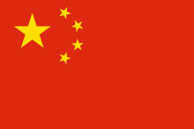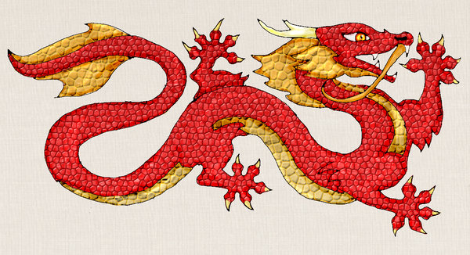
This Photo by Unknown Author is licensed under CC BY-SA

CHINA
UNITED NATIONS HUMAN RIGHTS COUNCIL

TOPIC: PROTECTING VICTIMS OF HUMAN TRAFFICKING IN CONFLICT AND POST-CONFLICT SITUATIONS
The Delegate of China would like to address on the topic of Human Trafficking Rates & Protecting the Victims. The Global Slavery Index estimates that on any given day in 2016 there were over 3.8 million people living in conditions of modern slavery in China, the prevalence of 2.8 victims of every thousand people in the country.

In 2016, the Chinese Ministry of Public (MPS) reported investigating 1004 cases of human trafficking and arresting 2036 suspects. Of those cases, 45 were suspected cases of post labour, involving the arrest of 14 suspects. In one investigation, the Chinese Government reportedly arrested 464 suspects who were involved in labour trafficking of disabled victims. The Government convicted 19individual for trafficking and 1302 individuals were convicted in cases in which exploitation was unclear.

As a criminal enterprise, trafficking has become an increasingly complex phenomenon in China, as traditional exploitative trends for forced marriage or adoption have in recent years being coupled with an increasing number of victims forced in to street performance, begging and theft. Organ trafficking has also emerged as lucrative business for traffickers.

The Chinese Government did not fully meet the minimum standards for the elimination of human trafficking and did not put on significant efforts to do so. Therefore, it ended up being placed on ‘Tier 3’ by US State Departments Office in 2017.

It was reported that China had “Arrested 19 of the country’s 20 most wanted traffickers” in pursuit of criminal networks and organized crime syndicates involved in trafficking.

The Government of China is taking a number of initiatives to prevent human trafficking such as “Save the Children” that has helped fund research to gain a clearer understanding into issues like migration, trafficking and street children to help promote safer migration. Another organization called “All China Women’s Federation” which is an anti-trafficking education campaign aimed at educating vulnerable women and children to protect themselves against prevailing social and cultural perspectives that propagate human trafficking. The penalties for the traffickers and buyers of the ‘human goods’ are very severe.

Submitted by-
Name: P Thaniskka
Country: China
Committee: United Nations Human Rights Councils

