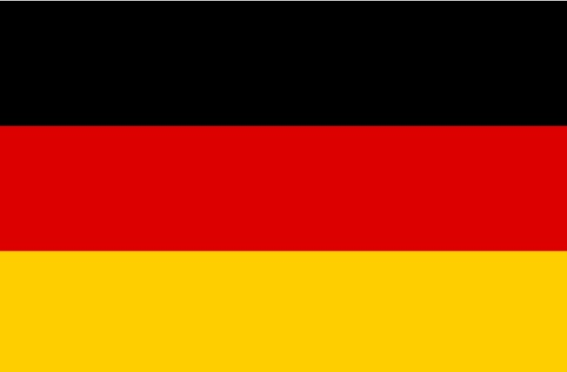
Country: Germany
Agenda: Information and Communication Technologies (ICTs)for Sustainable Economic and Financial Development
Delegate: Ashna.J
Adarsh Vidya Kendra

Germany, officially Federal Republic of Germany , is a country in Central and Western Europe . Covering an area of 357,022 square kilometers, it lies between the Baltic and North seas to the north, and the Alps in the south. It borders Denmark to the north, Poland and the Czech Republic to the east, Austria and Switzerland to the south, and France, Luxembourg , Belgium and the Netherlands to the west.

Previous Situation:
The role of Information and Communication Technology (ICT) is discussed both with respect to economic growth and green global modernization. ICT stands for the most innovative sector in the EU and USA. High productivity growth and digital product innovations are characteristic of this sector ; at the same time, ICT products are considered to be an enabling technology in other sectors. While digital technological progress may be anticipated – including the expansion of the internet- to contribute to raising efficiency and more green economic growth , there are considerable risks of rebound effects in the ICT sector. The findings for the impact of an green ICT in Germany shows small significant effect on output and relatively more important effects on the reduction of greenhouse gases. Hence the sustainable development in Germany and the EU, respectively.

Current Situation:
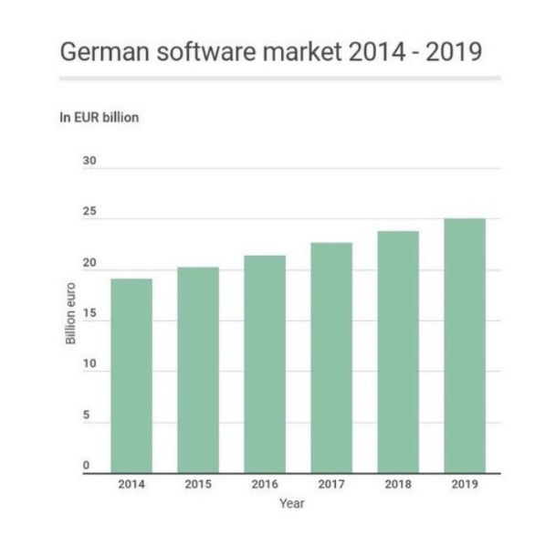
According to the German Federal Association for information technology , Telecommunications and New Media (BITKOM), ICT sales increased 2.0% in 2018 , to EUR 160.0 billion. This trend is expected to continue in 2019, with a 1.5% growth rate forecast.

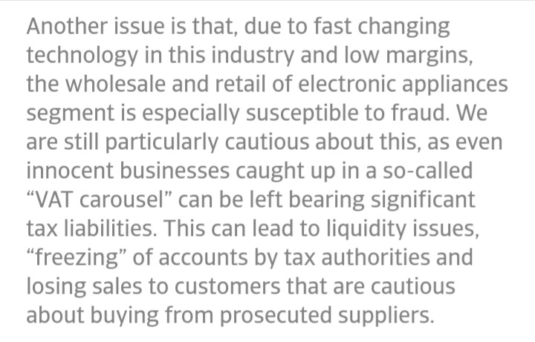
Problems:

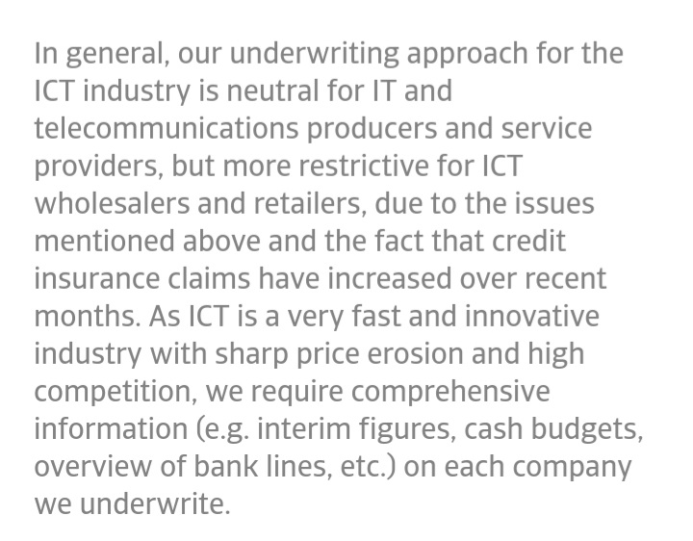
Solutions:

