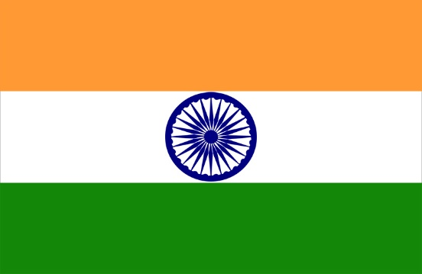

INDIA

TOPIC- conflict prevention and resolution
The Delegate of India would like to clarify the stances on the topic women’s conflict prevention and resolution.
- Women have played a greater role in conflict prevention and resolution. India has been training women peacekeepers from around the world. There is also increase and institutionalise involvement of women in conflict prevention and resolution.

- India has also taken the lead in hosting specialised training courses for peacekeepers on sexual violence in armed conflict situations.

- Over 40 women officers from around 30 countries attended the third such specialised course organised by the Centre for UN Peacekeeping in New Delhi in partnership with UN Women, the agency for empowering women and promoting gender equality.

- India has contributed in increasing the role of women in peacekeeping operations, India also made history in 2007 by deploying in Liberia the first all-women police unit in a UN peacekeeping operation and since then the percentage of Liberian women in the security sector had trebled.

- Even the Liberian President Ellen Johnson Sirleaf had acknowledged the contribution of Indian women police in “inspiring Liberian women, imparting in them the spirit of professionalism and encouraging them to join operations that protect the nation.

- India is committed to fulfilling the pledge to have 15% of military. India has also committed to provide another all-female formed police unit.

- Deputy secretary-general Amina J. Mohammed said that sexual violence was a legitimate threat to peace and women and girls had to be protected and empowered as a part of the counter-terrorism efforts.

Armed impact on women:-

- The impact of armed conflict on women and the need for effective institutional arrangements to guarantee their protection and full participation in peace processes.

- India had consistently held that greater participation of women in areas of conflict resolution, peace negotiations, peacekeeping and post-conflict reconstruction was the sine qua non for lasting peace and security.

- India attached high importance to ensuring concrete action in fully realizing the provisions of resolution 1325 (2000), and firmly believed that the national Governments had the primary responsibility for taking requisite action in developing national strategies and implementing them in pursuance of resolution 1325 (2000).

- Capacity-building was essential, and India supported United Nations efforts to deploy a greater number of women protection advisers and gender advisers in its missions.

- India also agreed with those who called for increased deployment of female military and police personnel in United Nations peacekeeping operations.

NAME- SNEHA PRAVEEN
COUNTRY- INDIA
COMMITTEE- UNGA ( United Nation General Assembly )

