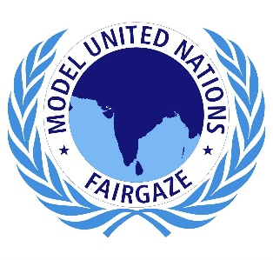
The Swiss Confederation
Unus pro-omnibus, omnes pro uno
Committee: WHO
Agenda: Medical Training in the Developing World
Country: Switzerland
Name of Delegate: Dhruti Rajguru
School: Navrachana School Sama

The emerging market economies are undergoing rapid demographic and epidemiologic transitions. The health of the population in most of these countries is threatened by the lifestyle-associated diseases, and new/existing infectious diseases. But the medical education of health professionals in these countries is not suitable to educate and train a workforce to deal with these health challenges. Some of the key challenges include a curriculum that does not meet the needs of the population, outdated teaching methods that include mainly didactic, classroom-based teaching, shortage of trained full-time teachers in clinical teaching, accreditation, and standardization of medical education in the increasing number of medical schools and inadequate teaching of bioethics.
Specialist training is very important in any health-care system. On top of primary there is a need for advanced knowledge and expertise in subspecialties. Hence a robust specialist training system is inevitable in the evolution of an independent, equitable, and sustainable system aimed at taking advanced health care to the population at large. There is a huge unmet need for specialist training in developing countries due to lack of local expertise.
Switzerland is one of the leading countries in medical training, with most of its schools included in the top 100 medical institutions in the world. Medical Training is to prepare physicians to apply the latest scientific knowledge to promote health, prevent and cure human disease and mitigate symptoms. Improving the quality of medical training is a priority of Switzerland. The Swiss Confederation is honoured to be ranked first overall out of 31 countries for the second straight year in the World Index of Healthcare Innovation. The healthcare system in Switzerland has a global reputation for being outstanding.
There are some key challenges to medical training that includes:
- Quality of training and education in the field of medicine is not up to the mark
- Resistance to change
- Lack of collaboration in medical education and practice
- Insufficient teaching and assessment capacity among the medical educators
- Insufficient teaching of Evidence Based Medicine (EBM) approach in medical curriculum.
We have taken some prominent steps listed below in the light of above challenges:
- Establish an inventory of the cooperation practices of Switzerland with developing countries in the area of health and medical education.
- Review cooperation practices in developing countries.
- The Swiss FOPH and the SDC established a team of public health professionals with HRH expertise, project management, to conduct a survey to identify “best practices” and evaluate the Swiss cooperation strategies to strengthen HRH.
- Chenot is a global wellness operator based in Switzerland. For almost 50 years, it has been specialising in integrating health into wellness and developing wellness programmes, treatments, cosmetic products, and food supplements that promote healthy living, wellness and successful ageing.
The Swiss Confederation firmly believes to enhance the medical training globally. The Switzerland Government pledges to continue to take beneficial steps towards a healthy society.

Regards,
Delegate of Switzerland

