POSITION PAPER OF ISRAEL

UNITED NATIONS GENERAL ASSEMBLY
DELEGATE NAME – ARIMA VERMA

AGENDA ITEM: Reducing Nuclear Danger

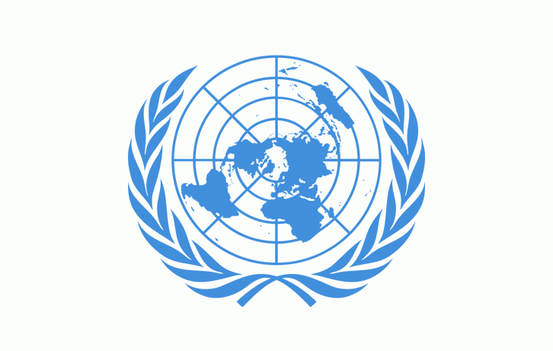Background:
As much as the Nuclear energy is Reliable and Carbon Free Energy, It is as much as Unsafe and Hazardous. Even a slight Mistake can cause the life of an entire town. The live example of this is the Chernobyl Disaster that took place on 26 April 1986 in Chernobyl, Ukraine due to the Blast of Reactor-4 of Chernobyl Nuclear Power Plant that spread Nuclear Radiation in the whole city causing people’s Death due to Cancer and other Radiation related diseases. And that is why Israel would like to Highlight a few points in How to Reduce Nuclear Danger.

Steps Already Taken:
Only a few steps are Taken by Israel to reduce Nuclear Energy in the past But It sure is Preparing for the future to be better.

Country Stance and Steps to be Taken in the Near Future:
- Reducing Nuclear Power Plants: As mentioned in the Above Example, Nuclear Power plants can be very Dangerous. So to
Reduce to the possibilities of repeating the Incident, Israel has
Decided to Reduce the number of Nuclear Power Plants in the
Country
- Reducing the use of Nuclear Weapons: We all know the condition
Of Hiroshima and Nagasaki after United States of America Detonated Atomic Bombs on these two cities of Japan during
World War (ii). These cities were not-habitable for Almost 75
Years. Though Israel do own Nuclear weapons, Due to its “Nuclear
Policy”, it cannot use them until necessary.
- Shifting to Solar Energy, Kinetic Energy Of Wind and Hydro energy:
These types of energies can be used as the substitute of Nuclear Energy to reduce the dangers.

So these are the steps taken by Israel to reduce Nuclear Danger.

