Position paper of
The Islamic Republic of Pakistan
United Nations General Assembly
Delegate name – Aarav Rawat
Agenda – Reducing Nuclear Danger
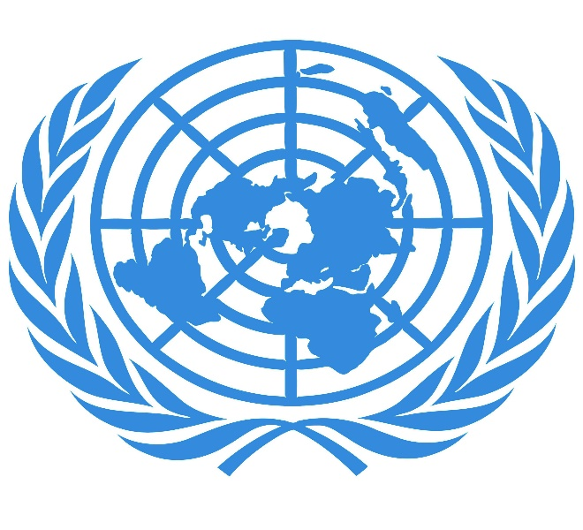
This Photo by Unknown Author is licensed under CC BY-SA
This Photo by Unknown Author is licensed under CC BY-SA-NC

Background:
It is no wonder that nuclear weapons are the most powerful and most dangerous weapons still existing in the world. After the bombing of Hiroshima and Nagasaki on the 6 and 9 of august in 1945 respectively and killing between 129,000 and 266,000 people. The world was shocked after the bombing because of the mass destruction caused by the nuclear bomb.
To try to prevent this issue three treaty was signed. One of them was the Treaty of the non - Proliferation of nuclear weapons (NPT) which was signed by 191 countries on 1 July 1968 and the other treaty was the Comprehensive nuclear – test ban treaty (CTBT) Which was signed by 185 countries on 10 September 1996 and the last which is recently signed is The Treaty on the Prohibition of Nuclear Weapons (TPNW) includes a comprehensive set of prohibitions on participating in any nuclear weapon activities. These include undertakings not to develop, test, produce, acquire, possess, stockpile, use or threaten to use nuclear weapons. The Treaty also prohibits the deployment of nuclear weapons on national territory and the provision of assistance to any State in the conduct of prohibited activities it has signed by 197 states on 20 September 2017
COUNTRY STANCE:
The Islamic Republic of Pakistan has adopted a position of “no first use” against non-nuclear-weapon states
The country got to acknowledge that there are approximately 13,890 warheads/nuclear bombs in the world out of that 3,750 are active warheads.
The countries Not having nuclear weapons have a larger threat/danger as they cannot protect themselves from a nuclear attack. therefore, the Islamic Republic of Pakistan states that there should be no further production, testing, or Research of such weapons so that the threat/danger of nuclear weapons can get under control and another suggestion is that everyone should agree to “no first use” policy which state that the country agreed to no first use policy will not use their nuclear arsenal against either nuclear or non-nuclear states only in case of an invasion against their territory or one of their allies.

