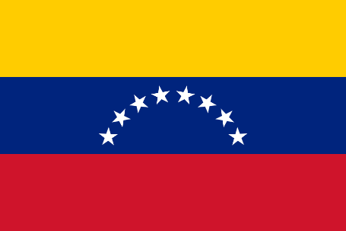**Position Paper – Bolivarian Republic of Venezuela**

**Committee: United Nations General Assembly (UNGA)**

**Agenda: Regulating Artificial Intelligence to Prevent Digital Colonisation**

**Country: Bolivarian Republic of Venezuela**

1. Introduction

Although the Bolivarian Republic of Venezuela acknowledges artificial intelligence's (AI) transformative potential, it is deeply concerned about its potential to be used as a tool for digital colonization. Strong nations and corporations control AI research, infrastructure, and data ownership in the absence of international regulation, which exacerbates global inequality and jeopardizes developing nations' digital sovereignty.

Digital colonization is a current reality rather than a hypothetical threat. In countries where they have little control over their design or ethical protections, AI systems are being used internationally, trained on global datasets, and impacting economies, governance, and culture. Using algorithms and digital infrastructure, this contemporary form of control replicates the colonial dynamics of the past.

1. Venezuela’s National Position and Initiatives

Venezuela is committed to technological independence and the ethical use of AI. The government has taken significant steps to resist technological dependence and ensure national control over digital infrastructure, including:

* Transparency, equity, human-centered design, and digital sovereignty were the main focuses of the National Artificial Intelligence Act's drafting, which is presently being reviewed by parliament.
* The Ministry of Science and Technology (MINCYT) has introduced a National AI Plan that prioritizes regional cooperation, local talent development, and AI research in public domains like agriculture and health.
* preserving data protection principles by means of legal prohibitions on cross-border data transfers without consent or comparable protections, as well as constitutional guarantees.
* fostering collaboration through the ALBA Alliance, in which Venezuela collaborates with Latin American countries to create autonomous AI solutions that are consistent with their shared social and cultural ideals.

1. Proposed Resolutions

Venezuela calls on the General Assembly to consider the following in order to stop AI from becoming a tool of global dominance:

* Create a global regulatory framework for AI development and application that is led by the UN and includes legally binding standards for ethics, accountability, transparency, and fairness.
* By means of international treaties that guarantee that data cannot be taken, sold, or used across borders without informed consent, protect each country's digital sovereignty and data rights.
* Establish an International AI Oversight Body to keep an eye on international AI systems and address any infractions or misuses.
* To guarantee fair participation in the digital future, assist developing countries in building their capacity through technology transfer, open-access AI tools, and educational initiatives.

1. Conclusion

Venezuela represents an inclusive, open, and equitable AI future. Digital freedom must not be sacrificed for digital advancement. To guarantee that artificial intelligence is used as a tool for collaboration rather than colonization, the UN must take decisive action. Building an AI-driven world that upholds the rights and dignity of all countries, not just the most powerful, will require regulation, accountability, and fairness.