POSITION PAPER
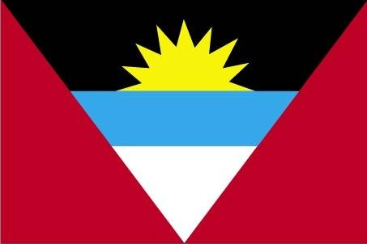
Country – Antigua and balbuda
Committee – World Health Organisation(WHO)
Topic – Medical training in the developing world

At least half of the world’s population cannot obtain essential health services. Medical training is an important aspect of a country’s development. Especially, for developing countries it is a vital point which contributes to overall development and progress. Medical facilities form a part of basic human needs. For better penetration of healthcare services in the developing world, training of medical professionals is extremely crucial and essential to benchmark learning and bring uniformity to patient experience. But, the growing population exceeds and outnumbers the present medical facilities which leads to the call for advanced medical training in developing countries.

Many countries today, lack a proper medical training system. outdated teaching methods that include mainly didactic, classroom-based teaching and issues related to appropriate standardization of medical education in the ever-increasing number of medical schools are some factors which form hindrance for a proper medical training system.

Being a developing country, Antigua and barbuda, acknowledges the demand for development in medical training. Antigua and Barbuda offers one of the best educational facilities with low tution fees to elevate the quality of education. The Island of Antigua has three foreign-owned medical schools, of which The American University of Antigua is the top-notch for medical studies, preferred by many international students. Antigua and Barbuda’s development in medical training is very much evident by the considerable increase in life expectancy. Life expectancy for the people of Antigua and Barbuda is 72.3 years old. This is one of the strongest indicators of the steady progress that the country is making. Since 1960, there has been an enormous jump from the previous life expectancy of 52.5. In addition to governmental programs, International, non-governmental, and national agencies provide technical cooperation in Antigua and Barbuda through grants, loans, and technical cooperation in the health sector.

The government has the most important role in this matter. Technology can make a major impact on healthcare in developing countries. Mobile technology can help countries in underdeveloped areas advance the design of administrative systems in healthcare. An important and vital step is to invest more and more in education, improving the quality of education. The cost invested in education is justified in the form of reduced expenses on healthcare and thus, counter. All medical students shall understand the level of seriousness because the chapter they earn today is going to save someone’s life tomorrow.

The road to achieving better medical training system is long and has numerous challenges. The world needs bold and drastic actions today, to achieve success in the medical field. It can be made possible with commitment and determination. Remember, all angels don’t have wings, some have stethoscope.

Submitted By: -
Name – Gurparas Singh
Country- Antigua and Barbuda

