About UNHCR
UNHCR, the UN Refugee Agency, is a global organisation dedicated to saving lives, protecting rights and building a better future for refugees, forcibly displaced communities and stateless people. We work to ensure that everybody has the right to seek asylum and find safe refuge, having fled violence, persecution, war or disaster at home.
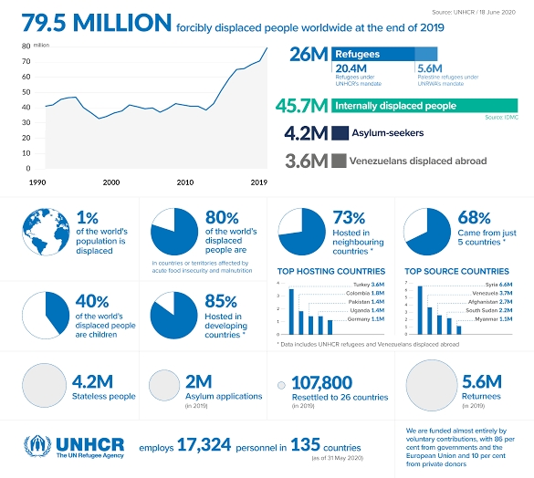

The World Health Organization (WHO) is working closely with global experts, governments and partners to rapidly expand scientific knowledge on this new virus, to track the spread and virulence of the virus, and to provide advice to countries and individuals on measures to protect health and prevent the spread of this outbreak.
UN's few workable steps:
Every day since the beginning of the pandemic, Rafael “Rafa” Sanz, a driver for the UN Population Fund (UNFPA) in Roraima, Brazil, follows a careful routine when arriving home. He takes off his shoes. He undresses and showers in an improvised stall in the backyard of his house. After spending the day helping protect migrants and refugees from COVID-19, he must be diligent to protect his family at home where his son is in declining health.
Education is the key to personal development and the future of societies. It unlocks opportunities and narrows inequalities. It is the bedrock of informed, tolerant societies, and a primary driver of sustainable development. The COVID-19 pandemic has led to the largest disruption of education ever.
As in other parts of the world, the health, economic and political impact of COVID-19 has been significant across Southeast Asia — hitting the most vulnerable the hardest. The pandemic has highlighted deep inequalities, shortfalls in governance and the imperative for a sustainable development pathways.
In the same direction India have displayed as a light house, and proved there an opportunity in every crisis:

Government of India and WHO partnership further strengthened to overcome the COVID-19 challenge
“Time and again the Government of India and WHO together have shown our ability, competence and prowess to the whole world. With our combined meticulous work, done with full sincerity and dedication, we were able to get rid of polio. Today I would like to remind you of your potential and ability, and the big things we can do together. All of you in the field – Integrated Disease Surveillance Programme (IDSP), state rapid response teams and WHO - are our ‘surveillance corona warriors’. With your joint efforts we can defeat the coronavirus and save lives,” said Dr Harsh Vardhan, Minister of Health & Family Welfare, Government of India at a virtual meeting held in New Delhi on 15 April 2020.
The Minister, along with Dr Poonam Khetrapal Singh, Regional Director, WHO South-East Asia, was speaking at an interactive session with senior officials and field officers of the World Health Organization (WHO) as well as key central and state government health functionaries on further strengthening the partnership and the additional measures that can be taken for effective containment of COVID-19 in India.
The key dignitaries present at the meeting were: Mr Ashwini Kumar Chaubey, Minister of State for Health & Family Welfare; Mr Sanjeeva Kumar, Special Secretary MoHFW; Health Secretaries and National Health Mission Directors from state governments/union territories and other senior officials from the Ministry of Health & Family Welfare (MoHFW), Directorate General of Health Services, National Centre for Disease Control (NCDC) and the Indian Council of Medical Research (ICMR) as well as key officials from the WHO South-East Asia Region Office and experts and over 1600 field personnel of WHO deployed across the country.
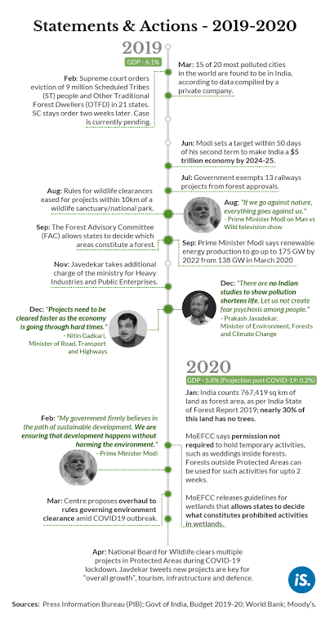
India
General Information
Government of India (Finance minister) announced the 24 March 2020 certain relief measures in view of COVID-19 outbreak.
- March 26: INR 1.7 trillion (~USD 22 billion) relief package announced by the Finance Minister

Tax measures – Direct and Indirect

(e.g. payment deferrals, rate reductions…)

Employment-related measures

(e.g. state compensation schemes, training…)
Food related
- About two-thirds of population will be covered under the Pradhan Mantri Garib Kalyan Anna Yojana (Food scheme)
- Everyone under this scheme will get 5 kg of wheat and rice for free in addition to the current 5 kg allocation for the next 3 months
- In addition, 1 kg of preferred pulse (based on regional preference) will be given for free to each household under this Food scheme for the next three months.
- This distribution will be done through Public Distribution Scheme (PDS) and can be availed in two instalments.
Direct benefit transfer related
- Farmers currently receive INR 6,000/- every year through the PM-KISAN scheme (minimum income support scheme) in three equal instalments. The government will now be giving the first instalment upfront for fiscal year starting April 2020. About 86.9 million farmers are expected to benefit from this immediately.
- MNREGA workers: Wage increase from INR 182/- to INR 202/-. Such increase will benefit 50 million families. The wage increase will amount into an additional income of INR 2,000/- per worker.
- 30 million senior citizens, widows, disabled to get one-time ex-gratia amount of INR 1,000 in two instalments over the next 3 months.
- 200 million woman Jan Dhan account holders to be given ex-gratia amount of INR 500 per month for the next 3 months, to run the affairs of their household.
- Women in 83 million families below poverty line covered under Ujwala scheme will get free LPG cylinders for 3 months.
- For 630,000 Self-help Groups (SHGs), which help 70 million households, the government is doubling collateral-free loans to Rs 200,000.
- State governments have been directed to use the welfare fund for building and construction workers. The District Mineral Fund, worth about INR 310 billion, will be used help those who are facing economic disruption because of the lockdown.
Healthcare related
- The Finance Minister has announced medical insurance cover of Rs 5 million per healthcare worker. About 2 million health services and ancillary workers will benefit from such insurance scheme.

Organized sector related – Social security
- The Employees Provident Fund Organization (EPFO) has announced - employees who contribute to EPF can withdraw upto 75 percent of the account balance or 3 months’ basic salary and dearness allowance, which ever is lower.
- Establishments which employ upto 100 employees and if 90 percent of whom earn upto INR 15,000 per month, the government will pay the employee provident fund contribution both of the employer and the employee (12 per cent each) for March 2020 to May 2020. This support is extended for another 3 months i.e. June to August 2020.
- Employer and employee contribution reduced to 10% percent each from 12% percent each currently for next 3 months (i.e. May, June and July 2020). This will applicable to all employer (other than government company and companies covered in bullet point no. 2 above)
- EPFO have extended the due date for payment of contribution for wage month of March 2020 from 15 April 2020 to 15 May 2020 (30 days grace period)
- Non-refundable advances may be granted to a member of a provident fund, subject to certain conditions.
- EPFO issued the circular which states that no proceedings should be initiated on establishments covered under the EPF Act for levy of penal damages on account of any delay in the payment of any contributions or administrative charges due for any period during the lockdown.
- In view of the government’s decision declaring COVID-19 as a pandemic, the Pension Fund Regulatory and Development Authority (PFRDA) allowed partial withdrawals from the NPS to fulfill financial needs towards treatment of the COVID-19 illness of a member, his/her spouse, children (including adopted child), or dependent parents. The following documents must be provided to claim a partial withdrawal:
  - Medical certificate; and
  - Formal request for partial withdrawal
Immigration
- Lockdown 1.0 - The entire country was on a 21-day lockdown from 25 March 2020 to 14 April 2020. All domestic and international travel had been suspended till further notice. Hence, travel in/out of India was restricted
- As per the Circular issued by the Ministry of External Affairs, foreign nationals who were stranded in India during Covid-19 crisis and whose Visa expired between 01.02.2020 and 30.04.2020 was granted an automatic extension of their Visa till 30.04.2020 after making an online application for the same
- Exit of such foreign nationals was also granted without levy of overstay penalty
- Lockdown 2.0 – All above mentioned changes extended till 3 May 2020. Further, foreign national can leave India upto 14 days from 3 May 2020 i.e. 17 May 2020 without levy of penalty for overstay
- Lockdown 3.0 – All above mentioned changes extended till 17 May 2020. Foreign nationals whose visa have expired or would be expiring during the period from 01.02.2020(Mid night) till the date on which prohibition on international air travel of passengers from India is lifted by the Government of India, would be extended on ‘GRATIS’’ basis on submission of online application by the foreigners. Such extensions would be granted for a period up to 30 days from the date of lifting of prohibition on international air travel of passengers from India without levy of overstay penalty.
- Lockdown 4.0 – All above mentioned changes extended till 31 May 2020.
- Visa free travel facility for OCI card holders who are not in India presently, has been kept in abeyance till the date of lifting of prohibition on international air travel of passengers.
- Any foreign nationals (including OCI cardholder) who intends to travel to India for compelling reasons may contact he nearest Indian Mission for fresh visa.
- Lockdown 5.0 – Lockdown is extended in Containment Zones upto 30 June 2020, and to re-open prohibited activities in a phased manner in areas outside Containment Zones.
- As per the press release issued by Ministry of Home Affairs on 1 June 2020 Government has relaxed the visa & travel restrictions for certain categories of foreign nationals who need to come to India. It has been decided to permit the following categories of foreign nationals to come to India:
  - Foreign businessmen coming to India on a Business visa (other than on B-3 visa for sports) in non-scheduled commercial/ chartered flights.
  - Foreign Healthcare professionals, health researchers, engineers and technicians for technical work at Indian health sector facilities, including laboratories and factories. This is subject to letter of invitation from a recognized and registered healthcare facility, registered pharmaceutical company or accredited University in India.
  - Foreign Engineering, Managerial, Design or other Specialists travelling to India on behalf of foreign business entities located in India. This includes all manufacturing units, design units, software and IT units as well as financial sector companies (banking and non-banking financial sector firms).
  - Foreign Technical specialists and engineers travelling for installation, repair and maintenance of foreign-origin machinery and equipment facilities in India, on the invitation of a registered Indian business entity. These could be for equipment installation, or is under warranty, or for after sales servicing or repair on commercial terms.
- The above categories of foreign nationals would have to obtain a fresh Business visa or Employment visa, as applicable, from the Indian Missions/ Posts abroad. Foreign nationals holding a valid long term multiple entry Business visa [other than B-3 visa for sports] issued by the Indian Missions/ Posts abroad would have to get the Business visa re-validated from the Indian Mission/ Post concerned. Such foreign nationals would not be permitted to travel to India on the strength of any electronic visa obtained earlier.
- Following categories of OCI Cardholders stranded abroad, have been permitted to come to India:
  - Minor children born to Indian nationals abroad and holding OCI cards.
  - OCI cardholders who wish to come to India on account of family emergencies like death in family.
  - Couples where one spouse is an OCI cardholder and the other is an Indian national and they have a permanent residence in India.
  - University students who are OCI cardholders (not legally minors) but whose parents are Indian citizens living in India.

Economic stimulus measures

(e.g. loans, moratorium on debt repayments…)
Liquidity measures
Relief measures announced by Reserve Bank of India on 27 March 2020 & 17 April 2020:
- Reduction of policy repo rate by 75 basis points (from current 5.15% to 4.40%)
- RBI will conduct auctions of TLTRO (Targeted Long Term Repo Operations) of up to three-year tenor of appropriate sizes for a total amount up to INR 2 lakh crore (~USD 26 billion) at a floating rate, linked to policy repo rate (50% corporates, 25% for development institutions for onward lending to agri, housing and medium / small enterprises and 25% for NBFCs and MFI)
- CRR of all banks to be reduced by 100 basis points to 3% beginning March 28, for 1 year. This will release liquidity of INR 1,37,000 crore across the banking system
MSF raised from 2% of SLR to 3% with immediate effect. Applicable up to June 30, 2020.
- Liquidity coverage ratio for banks reduced from 100% to 80% likely to release liquidity
- These liquidity measures will inject liquidity of INR 4.74 lakh crore (~USD 63 billion) to the system.
Relief for MSMEs
- INR3 Lakh crore (USD 39 bn) collateral free loan with 100% credit guarantee
- INR20k crore (USD 2.6 bn) subordinate debt for stressed MSMEs
- INR50k crore (USD 6.5 bn) equity infusion for MSMEs with growth potential and viability through Fund of Funds
- New definition of MSMEs – investment limit revised upwards; additional criteria of turnover introduced
- No global tenders for government contracts up to INR200 crore (USD 26 mn)
- E-market linkage to be promoted as replacement of trade fairs and exhibitions
- MSME dues to be cleared within 45 days
Relief for NBFCs
- INR30k crore (USD 3.9 bn) liquidity infusion for NBFCs/HFCs/MFIs
- INR45k crore (USD 5.9 bn) partial credit guarantee scheme for NBFCs
Relief for Power utilities
- INR90k crore (USD 11.7 bn) liquidity infusion to DISCOMs against receivables guaranteed by State government for exclusive purpose of discharging liabilities to power generating firms
Regulatory measures
- All lending institutions are being permitted to allow a moratorium of three months on repayment of installments for term loans outstanding as on March 1, 2020
- Lending institutions permitted to allow deferment of 3 months on payment of interest w.r.t all such working capital facilities o/s as of March 1, 2020
- Moratorium period to be excluded while computing 90 Day NPA norm for asset downgrade.
- Time period allowed under RBI framework for resolution extended by 90 days (210 + 90 days)
- Further deferring implementation of last tranche of 0.625 % of capital conservation buffer to Sept. 30, 2020
Real estate sector and EPC/Contractors:
- Extension of up to 6 months to be provided by all Central Agencies (like Railways, Ministry of Road, Transport & Highways, Central Public Works Dept, etc.)
- Government agencies to partially release guarantees, to the extent contracts are partially completed
- Registration and completion timelines extended by upto six months for all registered real estate projects
- Concurrent extension of various statutory compliances under RERA
Insolvency and Bankruptcy Code (IBC):
- Threshold of default under section 4 of the IBC has been increased from Rs 100,000 to Rs 10 million with the intention to prevent triggering of insolvency proceedings against MSMEs.
- Fresh admission of Insolvency cases for default arising after 25 march 2020 under IBC, 2016 suspended for six month (extendable by another six month) in an effort to stop companies at large from being forced into insolvency proceedings in such force majeure causes of default.
- Loans for COVID-19 excluded from definition of default
- Government to proposed new guidelines for MSME

Other measures and sources
Exports of medical equipment
- Prohibition on exports of following:
  - Surgical masks/disposable masks (2/3 ply), Textile material for masks and coveralls, All ventilators including any artificial respiratory apparatus or oxygen therapy apparatus or any breathing appliance/device, Sanitizers
  - Hydroxychloroquine (allowed on certain cases on a government to government basis only), Formulations made from hydroxychloroquine
- Restriction (export permitted under a license) on exports of Diagnostic kits
Imports of medical equipment
- Exemption from customs duty and health cess, (w.e.f .9 April 2020 to 30 September 2020) on import of following:
  - Artificial respiration or other therapeutic respiration apparatus (ventilators), Face masks and surgical masks, Personal protection equipment (PPE), COVID-19 testing kits
  - Inputs for manufacturing of aforesaid four items (subject to certain conditions)
Corporate affairs:
- No fees to be charged for late filing during moratorium period (01 April 2020 to 30 September 2020, 6 months) in respect of any document, return, statements, etc. required to be filed with MCA (Ministry of Corporate Affairs)
- The mandatory requirement of holding board meeting within 120 days of last meeting shall be extended by period of 60 days. Relaxation is till 30 September 2020.
Applicability of CARO, 2020 has been shifted to FY21 instead of FY20. (CARO is Companies Auditors' Report Order)
- Companies Act requirement of creating deposit reserve of 20% of deposits maturing in FY21 and investing 15% of debentures maturing in FY21 before 30 April 2020 may be done before 30 June 2020
- Decriminalization of certain defaults under the Companies Act 2013 and simplification of mechanism to deal with defaults
- Lower penalties for default of small companies, one person company, producer companies and start ups
- Companies permitted to list securities directly in foreign jurisdiction
- Private companies who list debt securities on stock exchange not to be regarded as listed companies
Measures to ease the lockdown
- Schools, Restaurants, Sport, and events are prohibited until May 17, National flights are Authorized for emergencies and certain needs

Unwanted and unexpected situations:
The Galwan Valley clash between India and China which started on 15th June, 2020, was a result of building tensions between the border forces of the two nations since May 5along the Line of Actual Control (LAC) that crosses through the valley in Ladakh. Such tensions have their roots, historically in the Sino-Indian War(1962), but more recently in both China and India’s expansion of military infrastructure along the LAC.
Top of Form
SEARCH
Bottom of Form

Top of Form

Bottom of Form

