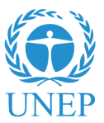
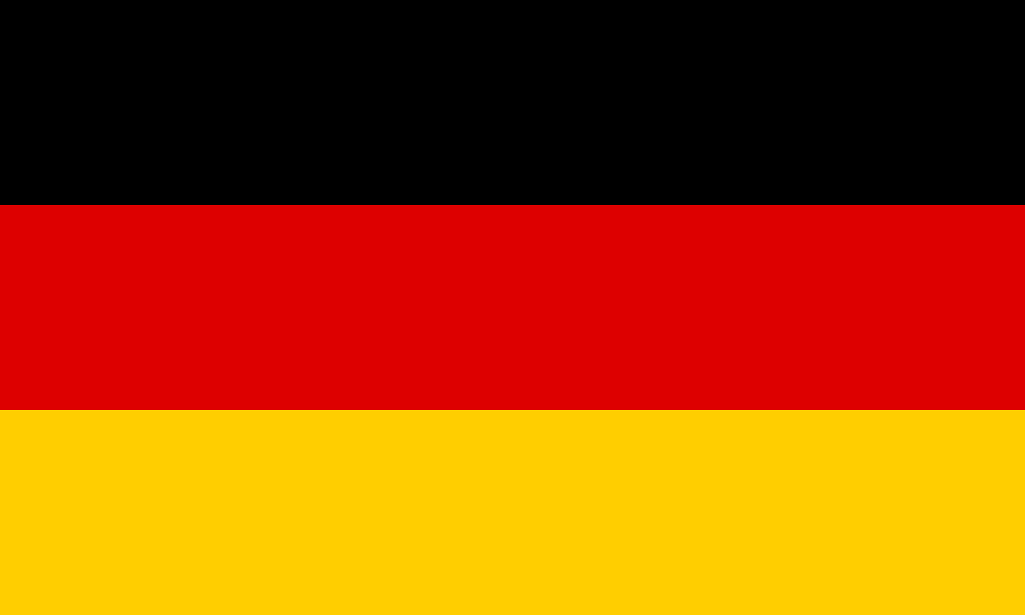
Position Paper

Country: The Federal Republic of Germany
Committee: United Nations Environmental Programme (UNEP)
Agenda: Promoting the Coherent Implementations of the Environmental Dimension of Sustainable Development

Country’s Position

Germany, being the third largest economy in the Organisation for Economic Co-operation and Development (OECD), has been proactive in developing ambitious environmental policies during the last decades, keeping the national and international aspects into consideration. The country’s strong environmental framework makes it not only a pioneer in environmental protection and sustainable development, but it also constitutes a good example on how a cleaner low-carbon economy is compatible with growth. In 2002, Germany adopted its National Strategy for Sustainable Development, making sustainability a guiding principle for national policies. Germany also launched major cross-cutting initiatives on biodiversity, climate change, energy and resource efficiency.

Country’s Relations

In its Energy Concept, Germany has formulated guidelines for an environmentally sound, reliable and affordable energy supply. The key elements of this concept are expanding the use of renewable energies and increasing energy efficiently, keeping the perspective of environment in consideration. Germany had also adopted German Resource Efficiency Programme, which entirely focuses upon addressing the sustainable utilization of raw materials. Germany’s main objective is to decouple economic growth as far as possible from the resource utilization, in order to reduce the burden on the environment and to strengthen the sustainability and competitiveness of its economy.

Country’s Proposals

- Germany aims at the reduction of greenhouse gas emissions by at least 80% by 2050.
- Germany aims at the much efficient implementation of various programmes like National Strategy on Biological Diversity, National Strategy of Sustainable Development, Resource Efficiency Programme, etc.
- Germany aims to raise the share of renewable resources from 17% to more than 80% in 2050

