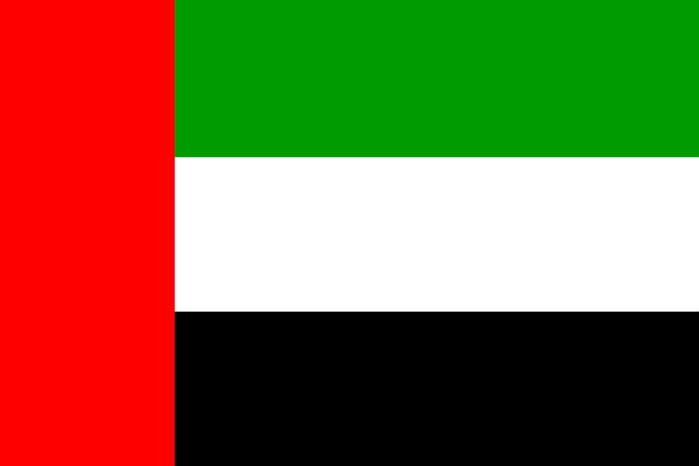
POSITION PAPER

COUNTRY: UAE
DELEGATE: Aaliya Thasnim. S
COMMITTEE: UNTWO
AGENDA: Restoring the Tourism Sector with COVID-19 Safety Protocols
COUNTRY’S OVERVIEW:
The United Arab Emirates sometimes simply called Emirates is a country in western Asia located at the eastern end of the Arabian Peninsula. It borders Oman and Saudi Arabia, and has maritime borders in the Persian Gulf and Qatar and Iran. Islam is the official religion and Arabic is the official language. The UAE’s oil, and natural gas reserves are the sixth- and seventh-largest in the world, respectively.

UAE AND IT’S TOURISM:
In 1989 the Dubai Commerce and Tourism Promotion Board was established, to promote Dubai as a luxury destination for the up-tier market and influential business sectors. In January 1997, it was replaced with the Department of Tourism and Commerce Marketing (DTCM).
In 2018, tourist industry composed over 164.7 billion dirham to country's GDP. The tourist industry of the United Arab Emirates is the most successful among the Gulf nations, and have long enjoyed status as the leading tourist nation of the GCC. The country is also the major tourist force in the Arab world.
COVID-19 IMPACT ON UAE’S TOURISM SECTOR:
Travel and tourism is a key pillar of the UAE economy. Without question, the travel and tourism industry has been one of the hardest hit by the pandemic and COVID-19 has dramatically changed the way people think about international travel.
Due to the pandemic, there is currently almost zero tourism in the UAE; most hotels were closed for at least two months and tourist attractions have closed for longer. Expo 2020 was set to be held in Dubai from October 2020 to April 2021. The expo area and buildings are the equivalent of building a whole new mid sized town in the UK and it’s currently finished but empty. There was a target for over 11 million additional foreign visitors to come to visit the expo alone, contributing to the tourism industry and the country’s GDP. The expo has now been postponed to October 2021.
RESTORING TOURISM IN UAE:
Rebuilding tourism is a priority, but the sector must become more sustainable and resilient in the future. The survival of businesses throughout the tourism ecosystem is at risk without continued government support and although governments have taken impressive action to cushion the blow to tourism, to minimise job losses and to build recovery in 2021 and beyond, more needs to be done, and in a more co-ordinated way. Key policy priorities include:
- Restoring traveller confidence
- Supporting tourism businesses to adapt and survive
- Promoting domestic tourism and supporting safe return of international tourism
- Providing clear information to travellers and businesses, and limiting uncertainty (to the extent possible)
- Evolving response measures to maintain capacity in the sector and address gaps in supports
- Strengthening co-operation within and between countries
- Building more resilient, sustainable tourism

