POSITION PAPER
COUNTRY: RUSSIAN FEDERATION
COMMITTEE: UNSC
AGENDA: PREVENTION OF WAR BETWEEN US AND CHINA IN CONTEXT TO CORONAVIRUS OUTBREAK.
DELEGATE: MUDITA SINGH NEGI
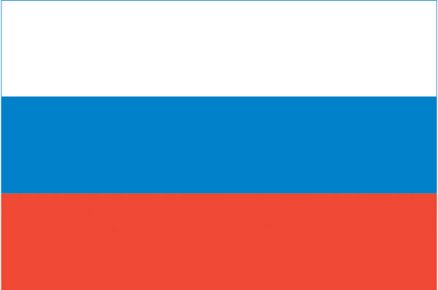
The coronavirus outbreak, which was first detected in China, has infected people in 185 countries. The outbreak of Coronavirus has created a havoc worldwide. During this time of pandemic, this virus has strained the US-China relations. Fresh tensions between Beijing and Washington emerged as virus restrictions continued to shape and remake lives around the world, and in very different ways.
With the researches on this virus are being held worldwide. Many countries have blamed china for the global spread of this virus.
USA has the highest number of positive cases with the lowest recovery rate.US President Donald Trump has been publicly blaming China for the global spread of the "invisible enemy". The President has claimed that he had seen evidence that proved the novel coronavirus originated in a laboratory. The United States accused China as well as Russia of stepping up cooperation to spread false narratives over the pandemic, saying that Beijing was increasingly adopting techniques honed by Moscow.
To this China replied, that its relations with the United States were "on the brink of a new Cold War," fuelled partly by tensions over the coronavirus pandemic.
Amid the lockdown Russia closed its border with China and banned Chinese nationals from entering the country. Shocked by Russia’s entry ban, the Chinese Foreign Ministry nevertheless said that Russian measures are understandable and emphasized that Beijing appreciates Moscow’s support to China against the epidemic. Russian officials clarified that the entry ban is a temporary measure and that Moscow will keep issuing business and transit visas to Chinese citizens.
Although China should have informed about the virus outbreak to the WHO earlier, But Russia is one of the first countries to extend a hand of support to Chinese doctors when they first started to fight the virus, then China started to help Russia by sending equipment.

