AVK FAIRGAZE MUN – 2021
WHO – POSITION PAPER
Country : CANADA
Committee : WHO
Agenda : Improving Access to Immunization and Halting the Spread of Vaccine – Preventable Disease.
About my country :
Canada is a country in North America. Canada occupies most of the northern part of North America. The country is bounded by the North Atlantic Ocean on the east, the North Pacific Ocean on the west, and the Arctic Ocean on the north.
It borders Alaska (USA) in the west, and twelve US states of the continental part of the United States in the south. Its border with its southern neighbour runs mainly along the 45th parallel (north). It is the world's longest international border between two countries .

Why Vaccine? 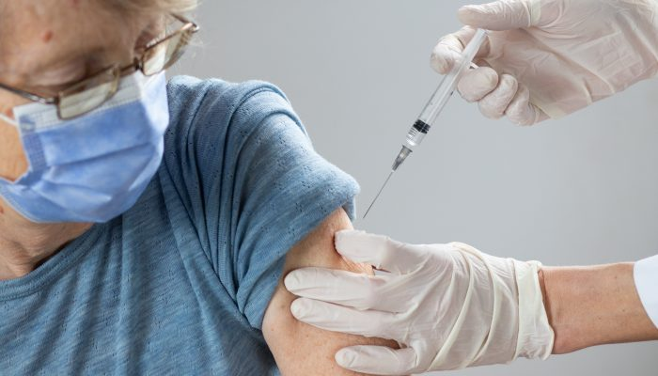
Vaccines prevent disease and mortality. They are the foremost achievement of public health programs in the United States and internationally. In the early 90s the National Vaccine Advisory Committee concluded that there were significant barriers to young children being fully immunized including inconvenient and limited clinic hours for immunization, inadequate access to health care, and vaccine administration fees. Barriers to adult immunization also have been identified. Immunizations, also known as vaccinations, are important for people of all ages. They help your immune system recognize and quickly kill bacteria and viruses that can cause serious illness or death.

What does my country do for improving the access to immunization?
In Canada, immunization programs are a shared responsibility across national, provincial, and local public health agencies . Public health agencies in Canada use a population health approach to improve the health of all Canadians and create healthier communities, including controlling infectious diseases through immunization strategies. The strategic and systematic approach to immunization allows for a population health approach while simultaneously ensuring outreach at a local level. As a health professional, it is important to familiarize yourself with the role and mandate of various organizations to ease system navigation, including where and when to access information.
Canada's immunization response involves collaboration between the Government of Canada, provinces, territories, First Nations, Inuit and Métis leaders, municipal governments, public health and logistical experts, manufacturers, and all Canadians.
CANADA’S TAKE ON COVID 19 :
While the immunization response is large and multifaceted, Canada is in a strong position to take on this challenge. This plan outlines Canada's approach to widespread immunization against COVID-19, with the first immunizations beginning as soon as possible to priority populations. Through advance purchasing agreements, enough vaccines have been secured to provide all Canadians with access to vaccinations. Immunization will begin with the arrival of limited doses, which will be prioritized to high-risk populations, such as the elderly, residents and staff of congregate living arrangements such as long-term care facilities, front-line health care workers, and those in living or working conditions with elevated risk for infection or disproportionate consequences, including Indigenous communities. Since the beginning of the pandemic, Canada's response has aimed to minimize serious illness and overall deaths while minimizing societal disruption as a result of COVID-19. In line with these overarching objectives, the goal of Canada's COVID-19 immunization response is:
To enable as many Canadians as possible to be immunized as quickly as possible against COVID-19, while ensuring that high risk populations are prioritized.

We each have an essential part to play in saving lives and protecting Canadian livelihoods. Governments recognize and understand the toll that the COVID-19 response has taken on our communities and are proud of the continued strength of commitment from Canadians to protect each other. So hence , we can hope that Canadians can emerge from this pandemic as a stronger and more resilient community .
Thank you…

