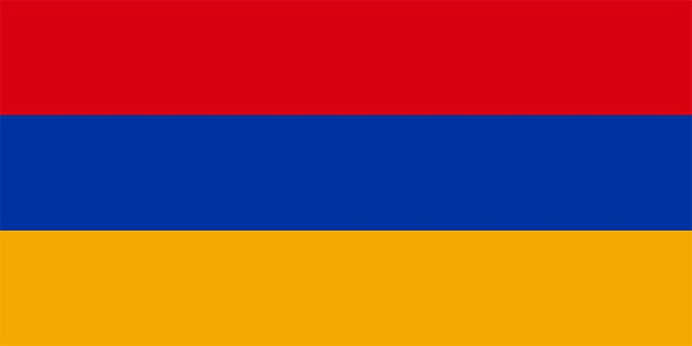
ARMENIA
COMMITTEE: (UNSC)
United National Security council
Agenda: Situation of Russia and Ukraine Conflict.

Introduction,
According to our agenda, we need to study on the Russia and Ukraine Conflict. Like depending on this leading question. What are the major problems which Armenia is facing due to conflict? , Whom the Armenia will support? , Relation between the Armenia and Russia/Ukraine? Who was with Armenia’s support in the past years? There will be a number of questions and problems waiting for the solutions, but for now we will focus on these hazardous problems in Armenia. We are breathing a free air in the 21st century, were sometimes problems occurs like a war going from 24 Feb 2007 who disturbed whole peace present in the world like every country there is one land Armenia, country of Transcaucasia, lying just south of the great mountain range of the caucasusand fronting the north-western extremity of Asia. Which is bounded by Georgia and east Azerbaijan?

Body,
Russia and Ukraine’s Conflict brought the worst and worst situation in the Armenia like
Armenia was in trouble to choose any one from both, this was because some major issues some of that were dependent on population. The largest Armenian communise are in Russia (2.25 million). And about half of Ukraine’s population is Armenian, these is the one of reason can be said Armenia can’t decide one country.
But it is seen in the past, war of 1988 Azerbaijan and Armenia the Ukraine was in the stand with Azerbaijan. But Armenians have been one of the most influential ethnic groups in Russia over the centuries, Armenia and Russia are both members of a military alliance, the Collective Security Treaty Organization (CSTO).
The Russo-Ukrainian War has left Armenia in a difficult situation. The state’s attempt to adopt low-profile neutrality on the issue has been met with criticism at home and abroad. Given the country’s circumstances, however, we thought it appears that this may be the best option currently available. But this was not for much time, on 06 April 2022 at least 23 Armenians died in the conflict. Like every country Armenia was requesting to get back there citizens. Over the weekend Yerevan saw two protests concerning the Russia and the other in solidarity with Ukraine and in opposition to the war also the rallies on anti-war protests on Sunday, the largest since the war began. Since the start of Russia invasion of Ukraine, thousands of Russian citizens the majority working in the IT sectors and passionately opposing Russia aggression have moved Armenia. The Armenia including poverty, high unemployment rates, corruption, and inadequate public services. Should be forgiven from the such problem country should be always peaceful and beautiful.

Conclusion,
In the above description, I delegate of Armenia has expressed/informed you some problems but in future if there will be any forced decision for be from any one, we will like to be with Russia, but more than that being a neutral is best decision, we always want to be in the peaceful and our beautiful world, the conflict shall stop and there is no problem to be a part of nato as we are to but if shall not matter the others because of conflict.

NAME- MR. UTKARSH BIRARI
COUNTRY- ARMENIA
COMMITTEE- UNSC

