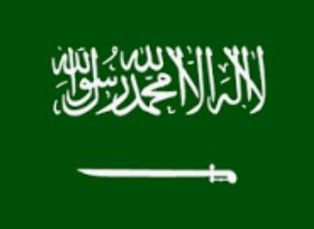
Committee: UNHRC
Topic. : The right to privacy in the digital age.
Country. : Saudi Arabia
Delegate. : Amirtha.R.A , Adarsh Vidya Kendra

The Kingdom of Saudi Arabia is the largest Arab country off the Middle East. It is bordered by Jordan and Iraq on North and North East, Kuwait, Quatar , Bahrain, and The United Arab Emirates on the East, Oman on the South East and Yemen on the South.
Saudi Arabia officially the Kingdom of Saudi Arabia, is a country in western Asia constituting the bulk of the Arabian Peninsula. Saudi Arabia is the only country with both a Red Sea coast and Persian Gulf Coast, and most of it's terrain consists of arid desert , lowland and mountains. The language is Arabic in Saudi Arabia.
Before, Saudi Arabia had many restrictions on womans,
- They are not allowed to open a bank account.
- They’re not allowed to get a passport or travel abroad .
- They are not allowed to marry or diverse without the permission of a male.
- They can’t grab coffee with a male friend.
- They can’t wear what they want.

But now, Saudi Arabia allows women to travel independently. The latter change has positive implications for the structure of the family. Within a family travelling should be a choice. Reaching this level of equality means the relationship between a woman and her father, husband or brother, should be based on trust, open communications, and a sense of responsibility. The new rule means the relationship between her husband and his wife becomes a partnership between two responsible adults, rather than guardianship of a minor. The new direction puts them as women in a place where they can gain individuality meet.google.com/mph-dvri-afd confidence in their ability to take care of themselves
Still in the Government of Saudi Arabia some restrictions are followed for the visitor
- No dabbling
- No wearing shorts
- Getting drunk on the flight over, are bringing in alcohol, could could land you in Serious trouble.
- Don’t bring in Drone without approval
- Don’t cut in line
- You can’t bring any pork into the country.
To solve this problem I have an idea: So, to restrict various things from visitors it could be easy to make sure that the visitor is not an illegal person. Saudi Arabia must not restrict the privacy of the foreigners like, asking them not to wear shorts .So it would be better if the Saudi Arabia government gives necessary rights for the women's to enjoy their privacy.

