POSITION PAPER
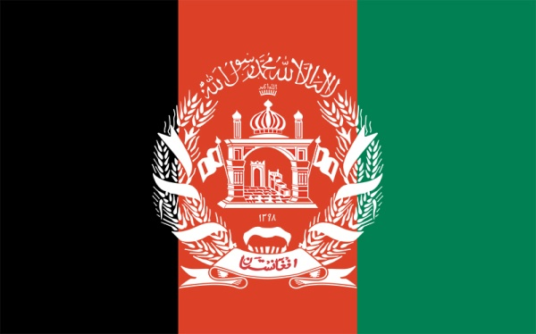
Name Of The Delegate:Shubham Sharma
COMMITTEE-UNHRC(MUN)
Country: Afghanistan
AGENDA:The issue of Taliban violence in Afghanistan

I delegate of Afghanistan would like to clarify the stance of the issue of violence by Taliban in Afghanistan. It is try to regain the sustain it victims there assistance and protection by many types of efforts.
CAUSE: Afghanistan was repeatedly terrorized and suffering from a very high geopolitical crises by the Talban enforcement in last few months and after the withdrawal of the US troops it lead to the occupy the whole Afghanistan by the Taliban, which led to the exploitation of the basic human right for the citizen of Afghanistan( specially women’s staying there).
SIGNIFICANCE- It is important to understand the status of an country terrorized and understand there fundamental causes of “Economic Crises”,which later let to there own downfall.

SIGNIFICANT HISTORY: It is popularly also known as “The Graveyard of Empires” as no one was able to completely conquer it.
Talking About some of its Historical Events:-
(1.) The “British” invasion in 1842, in the Taliban Afghanistan was betreated.
(2.) The withdrawal of the “Red Army” or “The Soviet Union” from Afghanistan in 1989.
(3.) The withdrawal of the US Army troops from Afghanistan.

CAUSES AND CONCERNS:-
All types of country who invaded Afghanistan state the reason to do this as they only wanted to civilize the country. King Amamullah Khan, in 1926 declares Afghanistan and the constitutional monarchy, and also proclaims to be called as “King of Afghanistan”, and later also the country came to be called as “Kingdom Of Afghanistan”.

Works He Done:-
(1.) Campaigned against polygamy multiple marriages.
(2.) Education of girls started schools.
(3.) Worked for equal right for women.
(4.) Right to Divorce.
(5.)Secular court and secular education free from religious Conservation.

THE TAKEOVER OF AFGHANISTAN:-
Ashraf Ghani left Afghanistan as it was take overed by Taliban troops ,reports say that he had reached either Tajikistan or Uzbekistan.
Many countries are sending their troops to rescue their citizen, 15 August 2021 Taliban take over Kabul, people rely their last hope on Afghanistan Kabul Airport to escape from Taliban.
One of the main reason that the Taliban take over Afghanistan was that because that the Afghani military was nearly causing no resistance towards the Taliban army, So much corruption , poor military training and lack of moral are also some of the reason for the occupication of Kabul, Taliban Afghanistan.

IMPACT ON THE COMMON CITIZENS:-
(1.) Women are kidnapped and forces to marry Taliban terrorists.
(2.) Many men’s are forced to fight for the Taliban Army.
(3.) There has been a very massive assignation of government officials.
(4.)The women are sustain with fear for their education.
(5.)Girls cannot even go out until an male relatives accompany them.
CONCLUSION: At last I conclude that the take overing of the Taliban is not beneficial for Afghanistan, personally I would assist that the us military should accommodate Afghanistan from Taliban.

