POSITION PAPER
COUNTRY: STATE OF LIBYA.
COMMITTEE: UNITED NATIONS SECURITY COUNCIL (UNSC).
TOPIC AREA: PEACE BUILDING MEASURES IN POST CONFLICT REGIONS WITH SPECIAL EMPHASIS ON IRAQ AND LIBYA.
DELEGATE: DEBANGSHI BHATTACHARJEE, FATHER AGNEL SCHOOL, NOIDA.
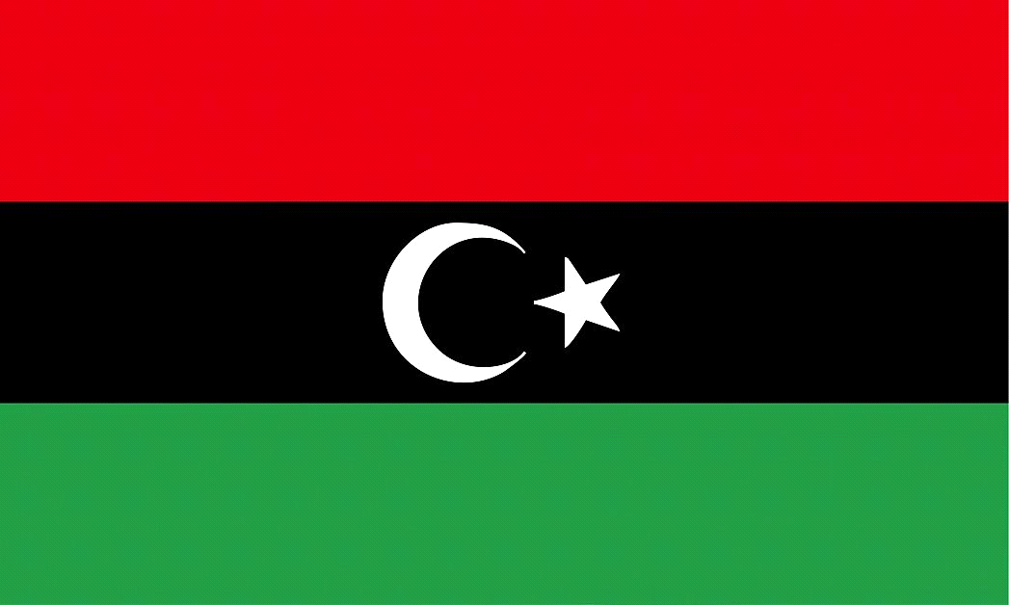
Violent conflict is one of the most profound of development challenges: without peace and security there can be no sustained development. In recent years, the international community’s discourse about addressing violent conflict and its consequences has become more nuanced. We increasingly recognize that humanitarian action, peacemaking, peace-keeping, peace-building, state-building, and development do not happen in a mechanical linear sequence, but are closely interlinked and overlapping. With the current issue, regarding post conflict regions, it has been no doubt that Libya has proven to be one of peace offenders due to its civil wars, bombing, etc.
However, it should be taken into account, that the national government provided various sources for its country citizens and was successful in suppressing the anti-government movement with little to no damage resulting. Libya had previously declared itself as one of the most highly economically developed countries in Africa, and continued to do so, even with the uprising of the army by General Khalifa Haftar. It should also be taken into account, that the support of the foreign countries who supplied both the parties, with numerous weapons, etc., was the root cause of several bombings and civil wars caused in Libya.
Keeping that into consideration, Libya has shown favourable efforts from both sides of opposition, despite the raging dispute against each other. Both the parties, on the request of Merkel, travelled to Rome to discuss the matter on hand, however, avoiding each other’s presence, which is a smart strategy, considering that both parties can cause potential harm to each other, if one or the other thing goes wrong, which would prevent the truce settling. Vladimir Putin, called on a truce the previous week for both the governments to engage in indirect talks. Even though, Haftar had left Russia without signing the agreement for a permanent cease fire, it was later reassured by Germany that he backed up the existing temporary truce.
In conclusion, given that the governments have agreed on a temporary truce, the delegate of Libya would like to suggest some solutions to prevent a conflict like this.
- Rule by Coalition:
Since one of the main reasons of conflict resides in holding the power of the country; a rule by coalition, along with the truce, would ensure that the governments hold equal power over the country to avoid any further damage caused by the battle of power.
- Temporary Withdrawal of Support from Foreign Countries:
The civil wars, and bombings, as aforementioned, were made possible with the provision of weapons by foreign nations. It would be of best interests, if the allies halt their supply of weapons, and engage in ‘civil discussions’ instead, for maintaining a proper peace.
- A Renewed Constitution:
A conflict is a result of disagreement on a certain topic. If both the parties sit together for a civilised meeting, with a peace assuring person present, they can form a couple of new laws that both the leaders agree upon. Later, they can hold a vote upon those laws, and thus create a new constitution that is agreed upon by both government and anti-government citizens.

