POSITION PAPER
Country: Turkey
Committee: UNHRC 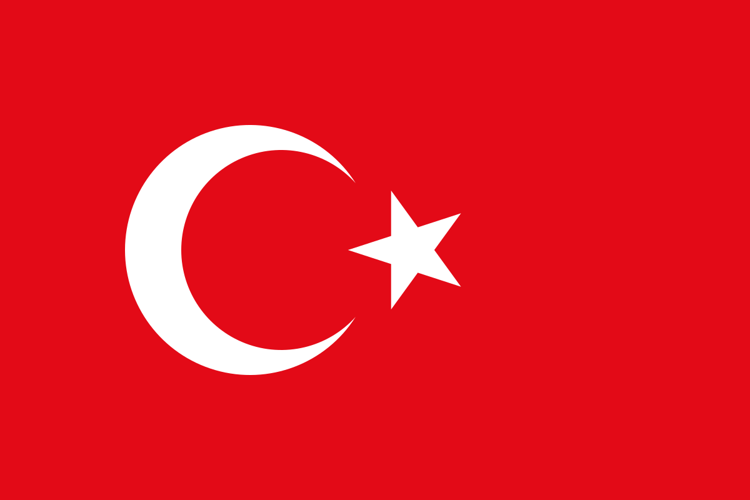
Agenda: Human Rights Offenses of Multinational Corporations
Turkey is a constitutional republic with an executive presidential system and a unicameral 600-seat parliament (the Grand National Assembly). In presidential and parliamentary elections in 2018, Organization for Security and Cooperation in Europe observers expressed concern regarding restrictions on media reporting and the campaign environment, including the jailing of a presidential candidate that restricted the ability of opposition candidates to compete on an equal basis and campaign freely.
In 2009, the Human Rights Foundation of Turkey released two reports detailing human rights abuses including torture, ill-treatment and isolation of small groups in prison. the reports documented 419 deaths in custody in a period of 15 years of military rule with 39 deaths recorded in prison in 2008 alone. Since then, human rights have been violated ( even though in a small scale ) in turkey

- Human rights in Turkey are protected by a variety of international law treaties, which take precedence over domestic legislation, according to Article 90 of the 1982 Constitution. The International Covenant on Civil and Political Rights (ICCPR) was not signed by Turkey until 2000.

- Turkey scored highest in the “Living” category, ranking first for “cultural, open and welcoming communities” and “ease of settling in

- Turkey has granted citizenship to 200, 950 Syrian migrants while 500,000 Syrian nationals have voluntarily returned home from Turkey as of March 31,

- Although its population is overwhelmingly Muslim, Turkey claims to be a secular country per Article 24 of the Turkish Constitution.
Article 26 of the Constitution guarantees freedom of expression. Articles 27 and 28 of the Constitution guarantee the "freedom of expression" and "unhindered dissemination of thought". Paragraph 2 of Article 27 affirms that "the right to disseminate shall not be exercised for the purpose of changing the provisions of Articles 1, 2 and 3 of [the] Constitution", articles in question referring to the unitary, secular, democratic and republican nature of the state.
We suggest to raise funds and have protests which will go to the preservation of human rights and create awareness in the country.

We aim to preserve and protect human rights.

