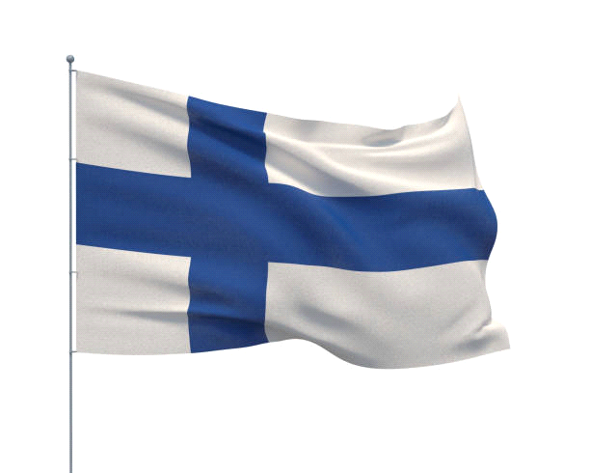
Finland is a Northern European nation bordering Sweden, Norway and Russia. Its capital, Helsinki, occupies a peninsula and surrounding islands in the Baltic Sea. Helsinki is home to the 18th-century sea fortress Suomenlinna, the fashionable Design District and diverse museums. The Northern Lights can be seen from the country's Arctic Lapland province, a vast wilderness with national parks and ski resorts. ― Google
President: Sauli Niinistö Trending
Capital: Helsinki
Dialing code: +358
Prime minister: Sanna Marin
Currency: Euro
Population: 55.3 lakhs (2020) World Bank
Official languages: Finnish, Swedish

With respect to foreign trade, the key economic sector is manufacturing. The largest industries are electronics (21.6 percent), machinery, vehicles and other engineered metal products (21.1 percent), forest industry (13.1 percent), and chemicals (10.9 percent)
economy of finland.
The economy of Finland is a highly industrialised, mixed economy with a per capita output similar to that of western European economies such as France, Germany and the United Kingdom. The largest sector of Finland's economy is services at 72.7 percent, followed by manufacturing and refining at 31.4 percent. Primary production is 2.9 percent.[22][23]

With respect to foreign trade, the key economic sector is manufacturing. The largest industries[24] are electronics (21.6 percent), machinery, vehicles and other engineered metal products (21.1 percent), forest industry (13.1 percent), and chemicals (10.9 percent). Finland has timber and several mineral and freshwater resources. Forestry, paper factories, and the agricultural sector (on which taxpayers spend around 2 billion euro annually) are politically sensitive to rural residents. The Greater Helsinki area generates around a third of GDP.[25]

In a 2004 OECD comparison, high-technology manufacturing in Finland ranked second largest in the world, after Ireland. Investment was below the expected levels.[26] The overall short-term outlook was good and GDP growth has been above many of its peers in the European Union. Finland has the 4th largest knowledge economy in Europe, behind Sweden, Denmark and the UK.[27] The economy of Finland tops the ranking of the Global Information Technology 2014 report by the World Economic Forum for concerted output between the business sector, the scholarly production and the governmental assistance on information and communications technology.[28]

Aviapolis, Vantaa is one of the most significant growing economic areas in Finland.
Finland is highly integrated in the global economy, and international trade represents a third of the GDP. Trade with the European Union represents 60 percent of the country's total trade.[29] The largest trade flows are with Germany, Russia, Sweden, the United Kingdom, the United States, the Netherlands and China.[29] The trade policy is managed by the European Union, where Finland has traditionally been among the free trade supporters, except for agriculture. Finland is the only Nordic country to have joined the Eurozone; Denmark and Sweden have retained their traditional currencies, whereas Iceland and Norway are not members of the EU at all.

