Position Paper
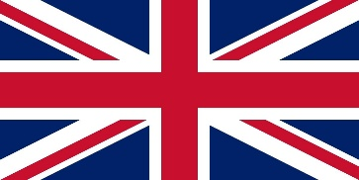

Country - United Kingdom
Committee - United Nations Human Rights Council (UNHRC)
Agenda - The Impact of unilateral coercive measures on the protection and enjoyment of human rights
Delegate - Aavya Vashisht

Human rights are the basic rights and freedom that belong to every one. Human Rights include the right to life and liberty, freedom from slavery and torture. It allows people to speak up when they experience abuse or corruption... the concept of Human Rights empowers people and tell them that they deserve dignity from society, whether it's the government for their work environment when they don't receive they can stand up.

A mature democracy with the well-developed legal system and especially because of Human Rights Act (HRA) passed in 1998, the United Kingdom does a reasonable job in protecting Human Rights at home, most people living in United Kingdom today have most of their core Human Rights respected most of the time. But some time it is violated by some people. In the form of discrimination, not to give freedom to accept the things. like
In June 2020, police used excessive forced against Black Lives Matter protesters and in December the northern Ireland policing board found policing of the protests to have been "Potentially Unlawful". While the police Ombudsman for Northern Ireland found it to have been " Unfair" and "Discriminatory" and later on they tried their hard to stop protest "I Can't Breathe" by issuing cases under covid-19 guise against protesters.
In June, an official investigation found that people of black and Asian ethnicity were found disproportionately impacted by COVID-19. In particular, Black and Asian health workers were significantly over-represented among COVID-19 related deaths of health workers.

There are some Human Rights that were Protect In UK Under The Human Rights Act:-
Right to life
Right to respect for private and family life
Right to personal liberty
Right not to be tortured or treated in an inhuman way
Right to a fair trial
Right to freedom of religion and beliefs
Right to freedom of expression
Right to non-discrimination
Protection of property -Protocol1
Right to education
No punishment without law
Freedom of assembly
Right to marry and found a family
Prohibition of slavery and forced labour... And many more

Taking action about Human Rights
Identify A Human Right Issue

What action you can take
√ Make an informal Complaint
√ Making a formal Complaint
√ Taking your complaint further
√ Taking Legal Action

