POSITION PAPER
ON
IMPROVING ACCESSIBILITY AND INCLUSION OF PERSONS
WITH DISABILITIES IN URBAN AREAS
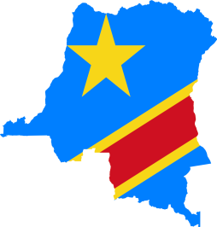
- COUNTRY: Republic of the Congo
- COMMITTEE:Commission on Population and Development (CPD)
- TOPIC : Improving Accessibility and Inclusion of Persons with Disabilities
in Urban areas
- DELEGATE: V.Rakshanaa , Adarsh Vidya Kendra.
The Democractic Republic of Congo is on track to pass its first law on the rights of people with disabilities,which could improve the lives of millions of people across the country.The DRC is among the poorest countries in Africa,where 89% of people live on less the $2 per day.The country is also affected by the civil war in Eastern DRC that has resulted in millions of deaths,injuries and massive population displacement over the past 20 years.The DRC is also regularly affected by epidemics(cholera,etc.)Increased exposure to natural disasters and widespread poverty and insecurity.The situation in the country has left the population highly vulnerable,especially people with disabilities.The disability federation estimates a prevalence of around 11% ,90%of persons with disabilities are illiterate and 96% live in inhuman form and degrading conditions.
The goal of TEAM Congo is to enable people with disabilities especially women and girls living in Kinshasa and Kananga to achieve independence and fully participate in all aspects of life.The project provides quality rehabilitation and orthopedic training to rehabilitation professionals,socio-economic oppourtunities,technical and mobility aid for those who require them.Humanity and Inclusion works to improve the case-management of disabilities and the care provided to victims of armed conflict in health care facilities and rehabilitation centres by training physical therapy students and strengthening the technical skills of existing physical therapists and has run a mother and child health program in the neighborhood of Bumbu Selambao in the capital of Kinshasa since 2008 with the goal of preventing and diagnosing disability in newborne.
HUMANITY AND INCLUSION EMPLOYS MORE THAN 128 STAFFS IN THE DRC TO:
- Offer logistics services.
- Enable people with disabilities to achieve independence.
- Support Organizations for People with Disabilities.
- Distribute food to vulnerable populations.
- Improve road safety.
- Provide technical support to local organizations
- Provide rehabilitation care
- Promote the rights and social participation of people with disabilities.
- Improve maternal and child health.

