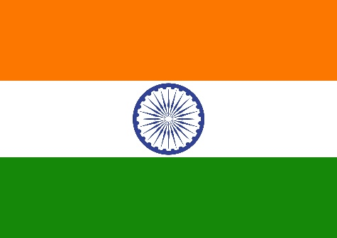
Country: India
Committee: United Nations World Tourism Organization (UNWTO)
Agenda: Restoring the Tourism Sector with Covid 19 Safety Protocol
Name of Delegate: Varun Sibi A P

The world is facing one of the most significant pandemics of the century, the COVID-19. The first case registered in December 2019, has grown to more than 3 Crore now. To contain the spread of the disease, the majority of the countries have imposed lock down and travel restrictions in their country. Due to this, business and trade have been affected severely. The travel and tourism industry is considered to be the hardest hit industry in these tough times.
The Indian Travel and Hospitality industry contribute largely to our GDP. According to WTTC, the industry contributed US $ 194 billion or 6.8% to the Indian GDP in FY2019. India ranked 10th among 185 countries for its spending on travel and tourism in 2019. India ranked 3rd based on investment in travel and tourism, amounting to the US $45.7 billion (IBEF,2018). As per IBEF reports, almost 4.2 crore jobs were created in the industry in 2019, a manifestation of enormous employment opportunities. As per a report by FHRAI, nearly 38 million people lost their jobs due to the Covid-19 pandemic in this industry.
The vaccine for COVID-19 will play an essential role in the revival of the industry. Many institutions around the world are working on developing it. Oxford has shown positive results, and if all goes well, we will have a vaccine by the end of the year.
The tourism sector is driven by people’s psychology, as they have become sensitive to safety and security. Institutions in the industry thought to gain trust by ensuring travelers with the safety and sanitization of the place. Several measures wll have to be taken in this respect, like disinfecting and sanitizing public areas, hotel, and travel vehicles.

