POSITION PAPER

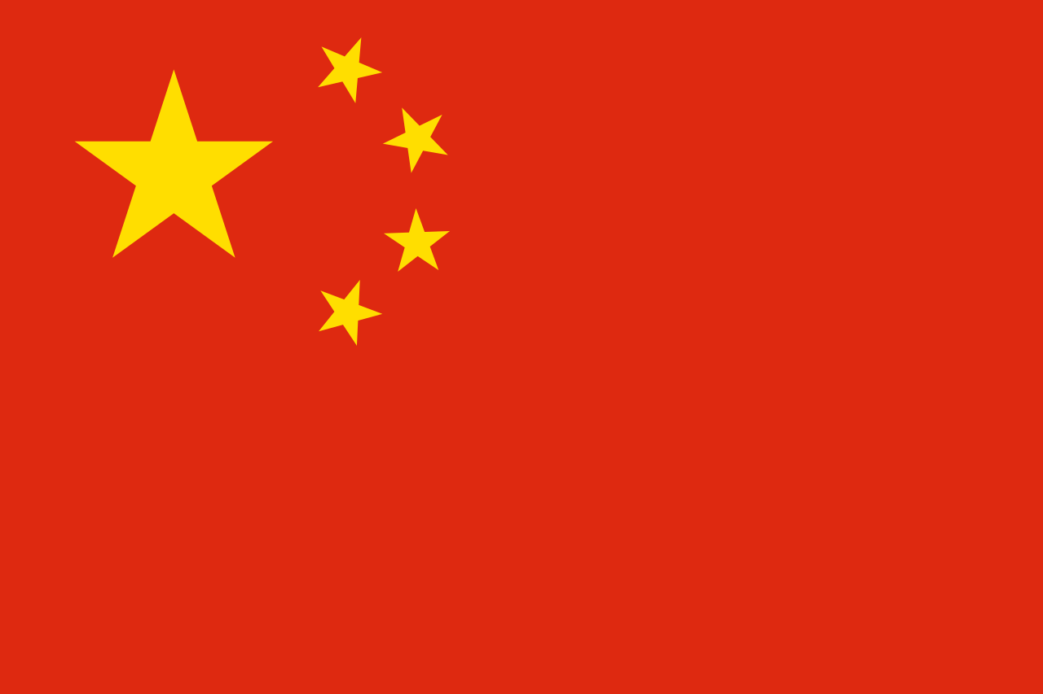
NAME OF THE DELEGATE: KRITIKA
COMMITTEE: ECONOMIC AND SOCIAL COUNCIL (ECOSOC)
COUNTRY: CHINA
AGENDA: IMPACT OF CORONA VIRUS ON INTERNATIONAL TRADE AND STRATEGIES MADE FOR POST CORONA SITUATION.
The new coronavirus, SARS-CoV-2, and the disease it causes, COVID-19, have created diverse, complex, and immediate challenges for world governments, multinational businesses, and other international institutions and projects. While the effects of COVID-19 are first and foremost a humanitarian issue, its effects also cut across many aspects of international trade, including supply chain management, business travel, immigration, manufacturing, sales, importing, exporting, customs, and logistics. Global trade fell at the fastest pace since the financial crisis in February as coronavirus hit Asia, in an early indication of the further deterioration in goods volumes that economists expect as the virus spreads around the world.
Compared with the previous month, global trade fell 1.5 per cent, the second consecutive contraction this year. As governments continue to act to respond to the virus, companies may begin contemplating significant and potentially far-reaching decisions to adjust to the new reality of COVID-19: questioning the reliability of supply chains and examining sales, operations, and manufacturing plans to react and adapt to new and rapidly evolving risk factors. The tariff and regulatory actions of the past several years have already led some companies to examine their international trade flows more closely. As events continue to unfold, a serious evaluation of changing suppliers, altering logistics routes, and updating sourcing will become more likely as companies navigate these events in search of a safe harbor.
“As Covid-19 causes factory outages and reduces spending across the globe, a wave of declining trade volumes follows the [spread of the] virus,” “Despite a fierce decline in trade volumes globally, the full extent of the Covid-19 crisis is still not reflected in these numbers.”
The delegate from China would like to inform that China recorded a 7.3 per cent fall in imports in January as it became the first country in the world to shut down parts of its economy in a bid to stem the spread of the virus; its imports dropped a further 3.2 per cent in February, the data published on Friday showed.
The delegate from China would also like to share the Chinese strategies for handling post Corona situation.China has set about rewriting international rules, premised not so much on governing where global goods are made, but on setting standards that define production, exchange and consumption. China Standards 2035 plans to set new standards with regard to the Industrial Internet of Things (IIoT) and define next generation information technology and biotechnology infrastructure. China is hoping, thereby, to reap the “early bird” advantage, even as other industrial nations struggle to recover from the devastation caused by the COVID-19 pandemic. Internationalisation of Chinese standards would provide China a clear advantage by providing it an opportunity to set the standards in emerging industries such as high-end equipment manufacturing, unmanned vehicles, new materials, cybersecurity and the like. This would enable it gain a dominant position in the global economy.
Recently our premier Li Keqiang came out with his strategy for mitigating the damaging effects of the epidemic for society and the economy it can be summed up in the short slogan, the “Six Protections”. These six protections are: job security, people’s livelihoods, businesses, food and energy security, stable industrial and supply chains, and the functioning of the lower levels of the Chinese government’s five-level hierarchy.
This slogan forms the core of the Chinese government strategy, and is integrated into the national leadership’s recent goals of ensuring stability in employment, finance, foreign trade, investment, and market expectations.Implementing the strategy will involve the national government both introducing new policies and strengthening existing ones. This includes allowing a ¥1 trillion (£115 billion) rise in the fiscal deficit and earmarking ¥1 trillion of special governments bonds for the as yet defined purpose of “COVID-19 control”. All this will to be transferred to local governments so that they can support employment, basic needs, and businesses.

