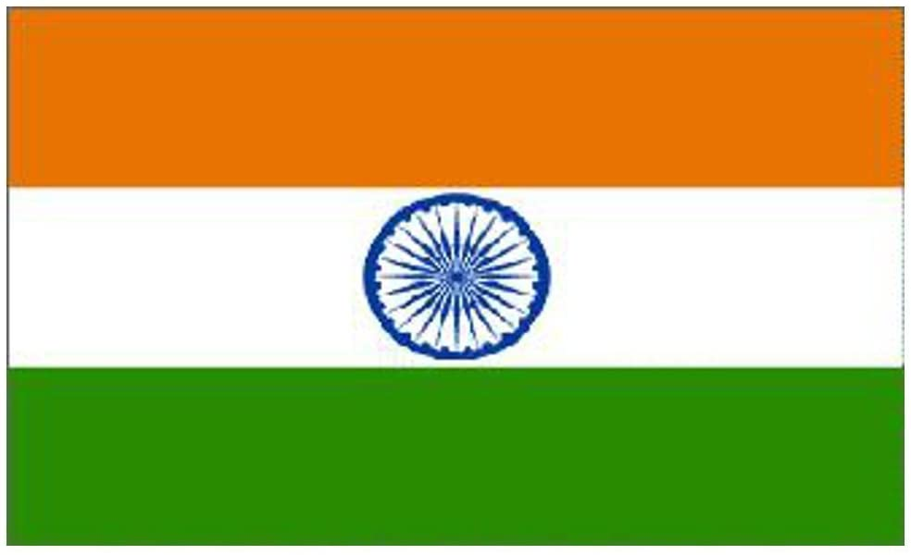
POSITION PAPER

NAME OF THE DELEGATE: TANUJ RAI
COMMITTEE: ECONOMIC AND SOCIAL COUNCIL
COUNTRY: INDIA
AGENDA: IMPACT OF CORONA VIRUS ON INTERNATIONAL TRADE AND STRATEGIES MADE FOR POST CORONA SITUATION.
The whole world is currently passing through a period of very serious crisis. Normally, when a natural crisis strikes, it is limited to a few countries or states. However, this time the calamity is such that it has put all of mankind in crisis. World Wars I and II did not impact as many countries, as have been affected by corona today. The outbreak of Coronavirus disease 2019 (COVID-19), first identified in Wuhan, the capital of Hubei, China, in December 2019 and since then having spread globally, has been recognized as a pandemic by the World Health Organization (WHO) on 11 March 2020. The pandemic has caused global social and economic disruption, including the largest global recession since the Great Depression. It has led to the postponement or cancellation of sporting, religious, political, and cultural events, widespread supply shortages exacerbated by panic buying. Schools, universities, and colleges have been closed either on a nationwide or local basis in 172 countries, affecting approximately 98.5 percent of the world's student population
India’s goal of becoming a $5 trillion economy has been set back by at least five, if not 10 years. The COVID-19 outbreak and subsequent lockdowns have severely disrupted economic activities. India's economy will shrink by 5 per cent in the current fiscal. The World Bank released its Global Economic Prospects report. It expects India’s gross domestic product (GDP) to contract by 3.2% in 2020-21.
Extraordinary times need an exceptional response.
The Delegate from India advocates for an immediate coordinated health response to suppress transmission and end the pandemic. A response that scales up health capacity for testing, tracing, quarantine and treatment, while keeping first responders safe, combined with measures to restrict movement and contact, a response that delivers universal access to treatment and vaccines, when they are ready.
Confident India will get growth back. India has full faith in the leadership of our P.M Hon’ble Shri Narendra Modi’s in leading India's capabilities to tackle the coronavirus crisis. The delegate trusts India's talent and technology, innovation and intellect, our farmers, SMEs, and entrepreneurs. That is why I say yes, India will get its growth back
For India, the coronavirus crisis should be seen as an opportunity, laying emphasis on domestic products and "economic self-reliance", an Atmanirbhar Bharat ( Self-reliant India) through a Atmanirbhar Bharat Abhiyan ( Self-reliant India Mission).
In conclusion ,Post Lockdown, India will inch closer to get economic growth back.
Making India self-reliant five things are necessary-intent, innovation, investment, inclusion, infrastructure
I would rather go beyond "Getting Growth Back" and say, "Yes, we will definitely get our growth back"
For us, reforms mean having the courage to take bold decisions and ensure that it is implemented in a time-bound manner.
India must reduce its dependence on imports and ensure that we make products in India. Products must now be "Made in India" and "Made for the world"
Growing outrage over China's perceived complicity in the spread of COVID-19 has given rise to this ‘Boycott China’ ethos in India, echoing a groundswell of similar anger in other countries. The trade war started by the US against China two years ago seems to be globalizing in the wake of the pandemic, as countries undertake a slew of anti-China measures that range from re-shoring businesses from China, creating alternative production chains, to stemming Chinese investments.
Today, the rest of the world holds India in high regard and has trust in our country. The world is looking for a trustworthy partner. India has the potential and capability to ensure that we are that partner. India has worked rapidly with a holistic approach that is being appreciated by not only Indians but also WHO.

