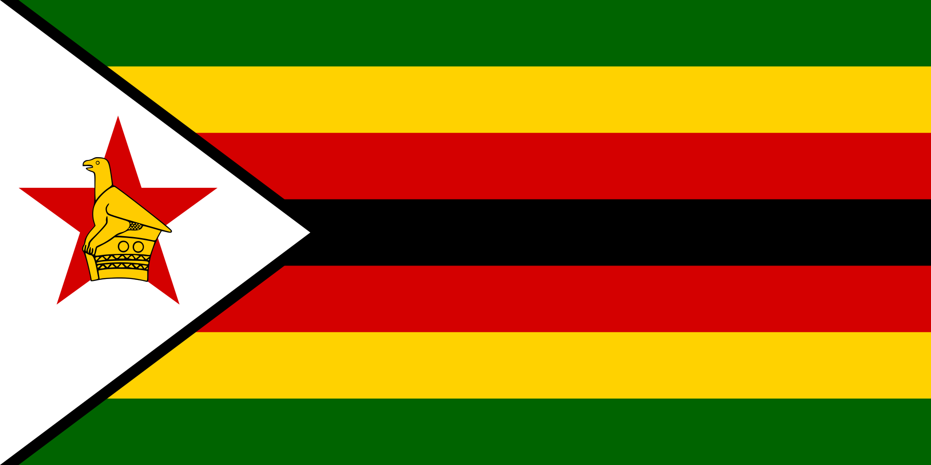 Position Paper 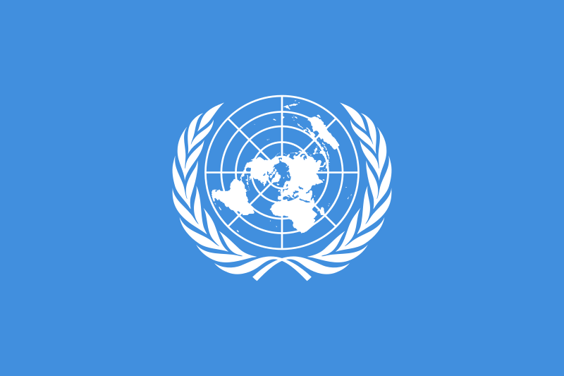
Committee - UNHRC (United Nations Human Rights Conference)
Country - Zimbabwe
Topic - Protecting Victims of Human Trafficking in Conflict and Post Conflict Situations

An estimated 45.8 million people live in modern slavery. The International Labour Organization estimates that global profits from forced labour surpass US$150 billion per annum, suggesting that slavery, forced labour and human trafficking are more profitable than the global arms trade. Today, non-state armed groups like Da’esh/Islamic State and Boko Haram actively promote slavery both as a means to finance themselves and as a method of war. There are mainly 3 areas to look into:
1) human trafficking within and into conflict-free areas;
2) child recruitment by non-state armed groups (NSAGs); and
3) human trafficking issuing from conflict-free areas.

Child recruitment by armed groups can also constitute human trafficking in conflict. Children are used by NSAGs as combatants, as sexual slaves and in supporting servitude roles (as porters, cooks, lookouts and intelligence-gatherers). Increasingly, children are forced to become suicide bombers. We are also witnessing a rapid increase in the online grooming and deceptive recruitment of children into NSAGs, for exploitation. This is an alarming new manifestation of human trafficking in conflict.
Refugees fleeing conflict are often subjected to traficking-related exploitation, including child labour, forced prostitution, forced and early marriage and forced begging.

- The parliament of Zimbabwe notes that child trafficking is one of the greatest challenges the country is facing as a result of the prevailing economic conditions.
- According to the international organisation for migration and intergovernmental United Nations agency that provides services and over sites around migration there are a number of cases of Zimbabwe and parents living in neighbouring countries who pay smugglers to unite them with their children in their new country.

Zimbabwe is organising training programs to educate people on the crime of human trafficking.
government through the ministry of public service labour in social welfare and civil society organisations in providing information through promotional materials such as flyers, banners, t-shirt, road shows throughout the countries provinces educate people on trafficking.
The government demonstrated significant efforts during the reporting period by securing its first convictions since 2007 and identifying and protecting more trafficking victims compared to the previous year.
The government trained border and law enforcement officials, labor inspectors, social workers, and civil society organizations on victim identification and interview techniques. The anti-trafficking inter-ministerial committee (ATIMC) met quarterly and led the implementation of the national action plan, and the government launched provincial task teams in five provinces, and conducted awareness raising activities.

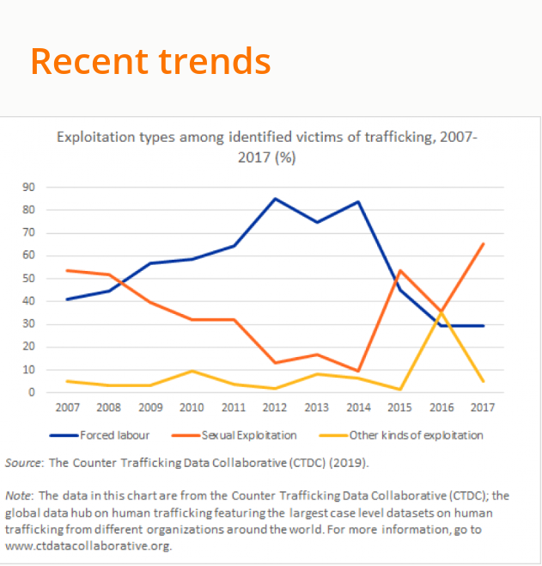

The government demonstrated increased protection efforts by adopting a national referral mechanism and referring all identified victims to care. The government reported identifying 10 victims and an international organization reported identifying 21 additional victims, for a total of 31 potential trafficking victims identified, compared with 87 total victims identified by officials and partners in 2017.

Countries national policy to deal with the issue

- In an effort to combat trafficking in persons, Zimbabwe ratified the convention on the 12th of December 2007. Zimbabwe acceded to the Trafficking in Persons Protocol on the 13th of December 2013.
- The Government of Zimbabwe then developed a Trafficking in Persons Bill which was enacted in terms of the Presidential Powers (Temporary Measures) Act into January 2014. These regulations were only for 6 months (January to June 2014) thereafter the Trafficking in Persons Bill was subsequently enacted and signed into law the Trafficking in Persons Act on 13 June 2014.
- The prohibition prevention and prosecution of the crime of trafficking in persons protection of victims of trafficking in persons.
- The establishment of an entry trafficking inter-ministerial committee and its composition and functions
- Establishment of centres for victims of trafficking in persons
- Matters connected with or incidental to trafficking in persons.
- The National plan of action is implemented in a way that does not discriminate against and among the victims of Tip on the basis of their nationality, race, colour, tribe, place of birth, etc.
- The Government of Zimbabwe ensures that the National response to combat trafficking is able to endure in the long term and will remain constant to the ever-evolving nature of Tip.
- In August 2014, training workshops for law enforcement officers were conducted in Kadoma, by the Ministry of Home affairs in partnership with IOM and UNODC to sensitise law enforcement officers of the new legislation, and to impart skills on how to conduct the victim centre investigations of TiP.
- This act provides for the establishment of centres for victims that are safe and secure from traffickers; offer counseling; psychosocial support specially for those with post traumatic stress disorder and rehabilitation of the centres that run care and development programs for victims.
- National Victim Friendly System and the Multi-Sectoral Protocol on Management of sexual violence are set up.
- A National Case Management System for welfare and protection of children has also been set up.

Treaties signed with other countries
- On 22 May 2019, Zimbabwe deposited its instrument of ratification of the Protocol of 2014 to the Forced Labour Convention, 1930 , thereby becoming the thirty-second country worldwide to ratify the Protocol. By ratifying the instrument, Zimbabwe is demonstrating its firm commitment to combating forced labour in all its forms.
- Zimbabwe has fully committed itself to Agenda 2030. Take immediate and effective measures to eradicate forced labour, end modern slavery and human trafficking.

Recommendations of the country
- Amend the anti-trafficking law to criminalize all forms of trafficking in line with the 2000 UN TIP Protocol.
- Increase efforts to proactively investigate and prosecute trafficking crimes, including complicit government officials and internal trafficking cases.
- Provide financial or in-kind support to NGO service providers.
- Expand training for law enforcement on investigative techniques.

Goals of the country

Goal 1. PROSECUTION
An effective criminal justice response and legal framework is established.

Goal 2: PREVENTION
Trafficking in persons is prevented

Goal 3: PROTECTION
The identification, referral and assistance system for victims of trafficking is established.

Goal 4: PARTNERSHIP/ COORDINATION
Coordination and cooperation at national, regional, and international level is ensured.

Conclusion
- 2014 Trafficking Persons Act prohibits trafficking and all illegal smuggling in the country.
- Standardised training is given to police and criminal justice officers to guarantee the proper security of the victims.b
- The Government of Zimbabwe is making significant efforts to come out the tragic situation of human trafficking. The government demonstrated overall increasing efforts compared to the previous reporting period; therefore Zimbabwe was upgraded to Tier 2.
- These efforts included sentencing a trafficker and increasing cooperation and coordination with NGOs to identify victims.

Source- www.unodc.org, www.protokoll-inland.de, www.reuters.com, www.indiatoday.in,

