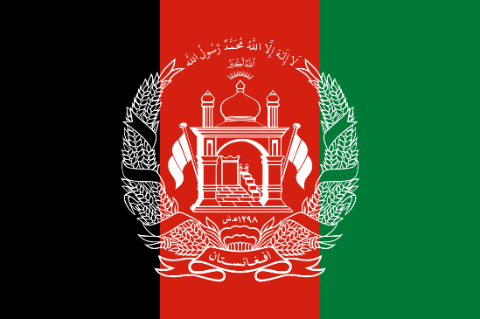
Name of the delegate: E.D. Anishka Sam

Country: Afghanistan

Committee: WHO

Agenda: Improving Access to Immunization and Halting the Spread of Vaccine-preventable diseases.

Vaccines are amongst the greatest advances of modern medicine. They have slashed child mortality rates in half, saving millions of lives. - UNICEF

Background

Disease in human beings is an impairment of the normal state that interrupts its vital functions. Some diseases may lead to serious complications and sometimes even death. Human beings often develop lifelong immunity when they have a disease. However, some infectious diseases such as Chickenpox, Hepatitis A and B, Measles, Mumps, Polio, Tetanus, Whooping Cough etc. can be prevented through timely vaccination. Vaccination aims to obtain immunity without any of the risks of having the disease. Vaccination against these diseases not only reduces the incidence but also reduces the social and economic burden on communities. Good immunization coverage can lead to the complete blocking of many diseases. The eradication of smallpox and polio are some of the examples of the usefulness of immunization.

Immunizations currently prevent 2 million to 3 million deaths every year. Despite the success, more than 1.5 million people worldwide die from vaccine-preventable diseases each year. Therefore, the World Health Organization is working with countries and partners to improve global vaccination coverage, through the new global vision and strategy - Immunization Agenda 2030. It aims to address the challenges over the next decade and save over 50 million lives. The WHO helps all countries to commit to immunization as a priority supports individuals and communities to understand the value of vaccines, and develops plans and materials to ensure every person is reached with vaccines.

About Afghanistan

Afghanistan is a landlocked mountainous country located in South Asia, which was found in 1709 and Kabul is the capital city. It is the 40th largest in the world in size with 652,860 km² land area and a population of over 3.8 crores in 2019. It is bordered by Pakistan, Iran, Turkmenistan, Uzbekistan, Tajikistan and China. Pashto and Dari are the official languages spoken. The average life expectancy is just 44 years, much lower than many countries. Afghanistan has been continuously affected by wars and internal conflict since the 1970s and more than a million Afghans have been killed and 3 million injured in internal conflicts.

Vaccine coverage and key issues in Afghanistan

The health of the people in Afghanistan has been steadily progressing over the last two decades, with increasing coverage of health services throughout the country. However, there is a lack of utilization of health services due to poverty, distance to health facilities, poor access to priority health services, low awareness, insecurity and shortage of health care providers, reduced donor support and inadequate domestic resources for health.

The immunization program in Afghanistan was launched in 1978 under the name “Mass Immunization Program” through the Ministry of Public Health (MoPH) and was gradually expanded to ensure universal immunization coverage throughout the country. However, conflict in the late 1970’s affected the immunization programmes which was further disrupted in 1999 under the Taliban regime. Despite the progress in recent years, Afghanistan is lagging in achieving the full potential of immunization. For example, maternal and neonatal tetanus continues to threaten the lives of mothers and children, polio is still endemic, and measles outbreaks continue to affect people. The overall immunization coverage remains low due to poor utilization of immunization services, poor distribution of healthcare services, security and other related problems. For example, according to Afghanistan Health Survey 2015, full vaccination coverage in Afghanistan was only 39%. Besides, the country was reported as one of the riskiest countries for children, with one of every 18 children dying before reaching their first year of birth which could be due to the low vaccination coverage.

Possible Solutions:

There is no doubt that the low vaccination coverage among Afghan children is of great concern and it is important to provide access to vaccines for saving lives and reducing child mortality rates. The following key steps are essential to improve the vaccine coverage.
- Given the complex factors affecting routine immunization in Afghanistan, focused research and studies are needed to understand practical approaches to communicate with different groups, for which support from international health organizations is essential.
- The international and national voluntary organizations must work closely with the government to reach out to the most unreached and generate demand for vaccination.
- The challenges affecting vaccine coverage must be addressed with proper planning and management of resources.
- As the country is facing a difficult economic and political situation, it needs commitment and continuous support from rich countries and UN organizations such as WHO and UNICEF, so that preventable diseases and deaths among children can be avoided and a healthy future generation can be ensured.

