Position Paper
Country : China
Topic : Food And Agricultural Organization (FAO)
Delegate : Ruthik Venkat.B from Adarsh Vidya Kendra School.
Favourite Quote: “ You only live once, but if you do it right, once is enough.” — Mae West.
Summarisation of my country:
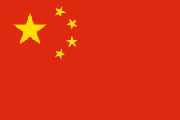
CHINA
China is the world's most populous country. It has a continuous culture stretching back nearly 4,000 years and originated many of the foundations of the modern world.

China is one of the world’s largest and most volatile customers for agricultural products. Yet, for a country of its size and limited resource endowment, its level of agricultural imports is modest. China tends to import bulk commodities and items used as intermediate inputs in labor-intensive manufacturing. China is a major exporter of high-value, labor-intensive food products, such as manufactured foods, animal products, fish, vegetables, and fruits. China’s agricultural exports go largely to other Asian markets.
The cooperation between FAO and China has contributed to the gains made in economic growth and increased food production of the country, which accounts for 21 percent of the world's population and only 9 and 6 percent of its arable land and water resources, respectively. China has made remarkable achievements in poverty reduction. According to China State Council’s official release in 2016, the country has lifted 700 million people out of poverty over the past 30 years. In October 2015, the Chinese Government has set the objective to eliminate rural poverty by 2020. This objective was subsequently listed as an obligatory index in China's 13th Five-Year Plan for Economic and Social Development. Innovation is the driving force for achieving a world free from hunger and malnutrition. FAO China has established an Innovation Lab (AgLabCx) focusing on several key national issues such as addressing the connectivity gap between smallholder farmers and market, through Information and Communications Technologies (ICT), or reducing food loss and waste. The lab creates a platform for generating innovative ideas and assists in incubating the best ones. It creates an enabling environment for people, especially the youth, to think out of the box, and raise up innovative and feasible plans with creative and entrepreneurial thinking. Innovation is more than technology. It is a complex process where multiple actors play different roles towards one common goal. FAO China is bringing governments, NGOs, foundations, institutions, academia, companies and other partners together to foster agricultural innovation and to create an environment that enables innovation in agriculture to flourish and generate solutions. For example, the China Foundation for Poverty Alleviation supported the FAO-Tsinghua Ag-LabCx to design innovative solutions for the development of Hani Terrace in Honghe County of Yunnan Province, which has also received strong support from the local government. China has become the leading country in promoting FAO’s Globally Important Agriculture Heritage Systems (GIAHS) Programme, boasting 15 out of the 57 enlisted GIAHS sites worldwide, including Rice Fish Culture in Zhejiang Province and Pu’er Traditional Tea Agrosystem in Yunnan Province. Through the GIAHS Programme, FAO China works with multiple stakeholders to protect agricultural biodiversity, indigenous knowledge systems, and resilient ecosystems, and to contribute to poverty reduction in rural areas. China is a pioneer in FAO's South-South Cooperation (SSC) Programme and remains a highly committed supporter, sharing knowledge and transferring its advanced technologies with other developing countries. In 2009, China donated USD 30 million to FAO through a Trust Fund to support the FAO-China SSC Programme (Phase I). In 2015, China and FAO signed a General Agreement providing for an additional USD 50 million Trust Fund in support of a second phase.
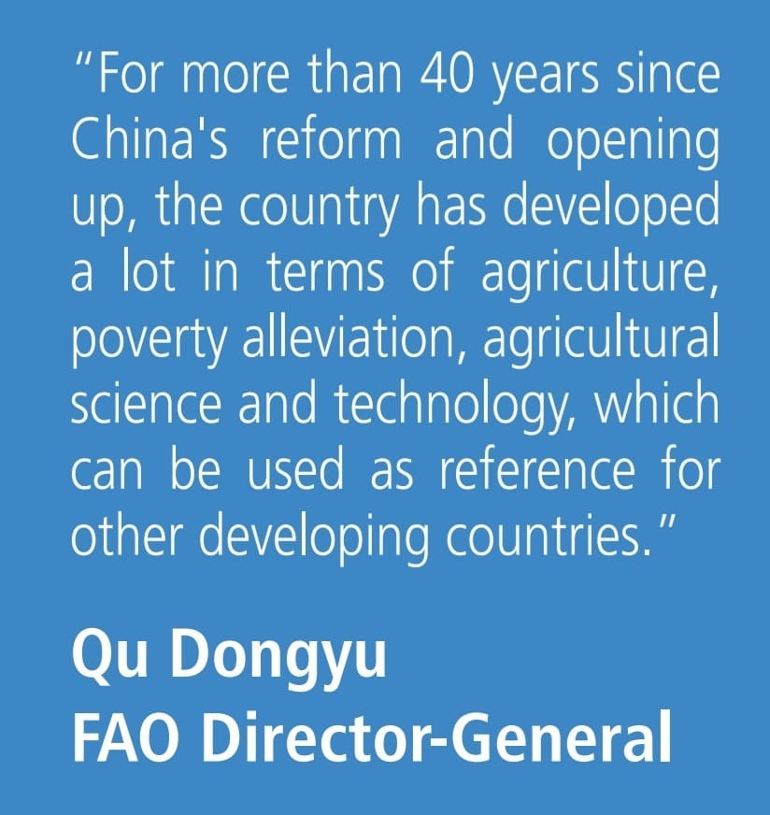
China’s vision is of a ‘world free from hunger and malnutrition, where food and agriculture contribute to improving the living standards of all, especially the poorest, in an economically, socially and environmentally sustainable manner’. To help its Member Countries realize that shared vision – individually at the national level and collectively at the regional and global levels – FAO and China organizes its work taking account of the main challenges facing the food and agriculture sector. The present study, which was undertaken for the quadrennial review of FAO’s Strategic Framework and preparation of the Organization’s Medium-Term Plan, 2018–21, lays out key global trends and challenges that will influence food and agriculture in the coming decades.The trends and challenges analysed here are cause for both hope and concern. Much progress has been made in reducing hunger and poverty and improving food security and nutrition. Gains in productivity and technological advances have contributed to more efficient resource use and improved food safety. But major concerns persist. Some 795 million people still suffer from hunger, and more than two billion from micronutrient deficiencies or forms of overnourishment.

