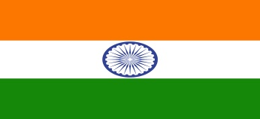
Country: India
Committee: United Nations Security Council
Topic: Improving Effectiveness in Peacekeeping

• Indian records- India has always played a major role in UN Peacekeeping. Up until now, more than 244,500 Indians have served in 49 of the 71 UN peacekeeping missions established around the world since 1948.
• India’s issues- For a long time, Terrorism has been a great concern for the nation. India believes that domestic measures alone cannot deal with Terrorism as long as countries continue to provide them with resources so we must tackle the sponsors as well.
• Actions taken- In this fight against Terrorism, the nation took the initiative to pilot a draft Comprehensive Convention International Terrorism (CCIT) in 1996. India also supports strict global implementation of anti-terrorism mechanism established by UNSC.
• Incident- India, recently, handed a dossier to the five permanent members of UNSC about a major attack that said militants from Pakistan had attempted in the Indian part of Kashmir. Although the Security forces killed all four of them, such issues need to be taken care of ASAP.
