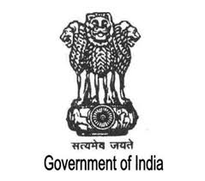

JP. Nadda Residence address Member of Rajya Sabha 7-B, Motilal Nehru Marg
(Himachal Pradesh) New Dehli :President of Bhartiya Janta Party Ph:8800633377
Web: https://jagatprakashnadda.in/
Date:20th August 2020
Agenda : Discussion on police brutality in India and new legal reforms to strengthen the justice system.

AIPPM
Policy Statement

The police is the force of the nation which works day and night to maintain justice and peace in the country. Police Brutality is often takes birth from personal grudges. For example a police officer has long and bitter history with a citizen. Even for a minimal crime the police officer will punish the citizen severely , taking out his frustration.
I believe that, until every government worker either police or some other department employee does not walk the path of selflessness India cannot thrive.
We have to discourage people to take shortcuts or cheat the country.
We the politicians and leaders should be the example for our citizen. Before taking any step , making any speech we should ask ourselves a simple question : “would this benefit my country?”
JP. Nadda
President of BJP

