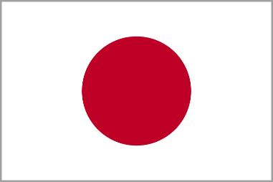
POSITION PAPER
Agency - Japan
AGENDA - Ensuring Sustainable Consumption & Production
INTRODUCTION OF COUNTRY
Japan is a country situated in North – Eastern side of the world in North Pacific Ocean. It’s capital is Tokyo. It’s president is ‘Shinzo Abe’. The prime minister of Japan is ‘Yoshihide Suga’. Japan joined the UNITED NATIONS in 1956 on 18 December.
Our country gives special attention on our agenda. We have also signed a deal with our one of the best friend India to give them Bullet Trains. Our country dosen’t have enough raw material for making new machines.
HOW THE ISSUE AFFECT THE COUNTRY
- We are not able to export the exact quantity of material asked by another countries.
- As a result we are having low GDP and economy.
GDP RATE OF JAPAN (going less)
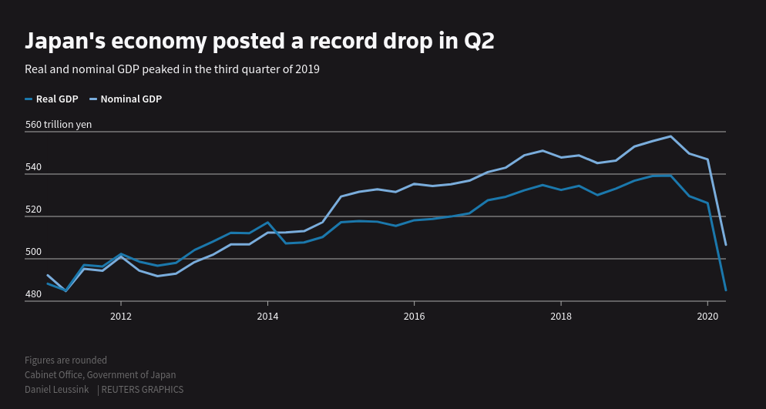
KEY ACHIEVEMENTS OF JAPAN
- Japan has developed and recovered itself from COVID-19 situation.
- It is having less than 1000 cases per month.
- It has been successfully vaccinated thus there is no lockdown in Japan like any other country.
Actions taken by the government with regard to the current issue.
- Our government has been very co-operative in this situation.
- With the help of our honourable prime minister ‘Yoshihide Suga’ and their members, our country has appealed to UN to provide us more raw material by air routes to be faster in supplies.
- Our government also demanded for raw material with its friendly country.

WHAT THE COUNTRY BELIEVES SHOULD BE DONE

- Our country believes that we should decrease the production of goods till the time un helps us and also not gather at industries now in this COVID-19.

POSITION OF OTHER COUNTRIES AFFECTING OUR COUNTRY’S POSITION

- Japan expenditure was 27.6% in 2014. It is 3rd largest country in producing goods.
- Japan architecture, art, tradition, crafts are so famous. It is also known world wide because of its anime, video games, etc.
- Japan most people are from 45-59 years of age group.
