Position paper

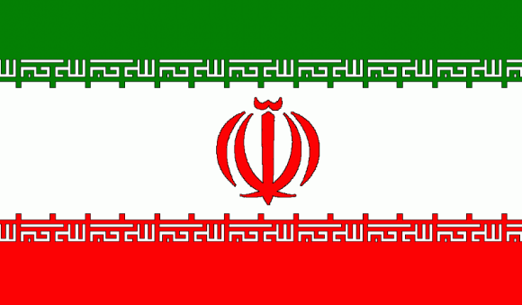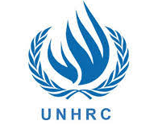

NAME: Mayank Chaudhary
COUNTRY: Iran
COMMITTEE: United Nations Human Rights Council (UNHRC)
AGENDA: Protecting victims of human trafficking in conflict and post-conflict situations.
Trafficking in persons shall mean the recruitment, transportation, transfer, harboring or receipt of persons, by means of the threat or use of force or other forms of coercion.
Causes of human trafficking in conflict in Iran:-
Trafficking in Iran is always fueled by political instability and happens on a regular basis in the context of large migration flows. Forced labour and slavery have been found to be a strategy for terrorist groups such as ISIL/DAESH, Boko Haram and others in Iran. These gross human rights violations are systematically perpetrated in the context of any conflict or in areas at risk of conflict by criminal or armed groups which take advantage of the breakdown of the rule of law to carry out the dirty business of trafficking and become more powerful and dangerous. Human rights violations such as trafficking in persons are not only a consequence but also a cause of conflict in Iran.
Causes of human trafficking Post-Conflict in Iran:-
In Iran Post-conflict periods seem to foster a rapid increase in organized crime. There are several reasons for this. It often takes several years to reconstruct an institution in a country, and the lack of legal framework and functional institutions results in a relative impunity for the perpetrators of trafficking of all sorts, including trafficking in human beings in Iran. Many former warlords who derived their income from arms trafficking , pillaging and other arbitrary taxes they collected, try to build a new business for themselves engaging in organized crime (trafficking in drugs, cigarettes and human beings) to offset the financial shortfalls resulting from the end of the war. Their influence on the structures of the State as a result of their former relations, and the money accumulated during the war and now used to corrupt key people, often give them a form of immunity for many years.
UNHRC role in protecting victims of human trafficking in conflict and post-conflict situations in Iran:-
The United Nations Office on Drugs and Crime in the Islamic Republic of Iran established a country office in Tehran in July 1999, following the signing of a Memorandum of Understanding between the Government of the Islamic Republic of Iran and the UNODC. UNODC technical assistance on drugs and crime to the Islamic Republic of Iran was delivered in the framework of the NOROUZ (Narcotics Reduction Unitized Programme) programme. UNODC chose the Persian word ‘‘NOROUZ’’, meaning "New Year", to symbolize the opening of a new era in the national drug control effort and in the participation of the international community to its realization.
The main objective of the ''NOROUZ'' programme in Iran was to work with the government counterparts in a participatory manner in order to minimize the impact of the drug problem in the country. Through the implementation of multi-disciplinary actions embracing supply reduction, demand reduction, legal assistance, and advocacy, the Programme has been successful in enhancing national anti-drug trafficking capacities, reducing the impact of drug abuse improving legislative capacities, disseminating information, and mobilizing and empowering civil society in the fight against drugs and crime.
Moreover, as per UNHRC, trafficking should be addressed in connection with the Women Peace and Security Agenda and with the Six Grave Violations against Children during Armed Conflict Agenda. In fact, a particular concern relates to the situation of children, who are used as child soldiers or sexual slaves during conflict, are disproportionally affected by displacement, often traveling alone to reach a safe country and being subject to any form of trafficking, exploitation and abuse. It is always an obligation under international law to protect them . In this context, States should ban detention of children for violations of immigration laws and regulations in Islamic Republic of Iran.
Conclusion: -
IRAN Country must respond quickly and effectively, adopting a shared responsibility approach, to incorporate anti-trafficking into all humanitarian interventions in conflict zones as a life-saving activity, to establish wider channels for regular migration, to ensure full respect of the principle of non-refoulement, to implement relocation in a preferred country, family reunification procedures, effective child protection systems, as powerful means to prevent trafficking, and simultaneously to ensure stability, peace and security.
I am convinced that trafficking in persons in the context of conflict and post-conflict situations, trafficking of persons fleeing conflict and the protection of the rights of victims and potential victims require urgent, concerted and effective action in Iran.

