UNITED NATIONS HUMAN RIGHT COUNCIL.
AFGHANISTAN.
POSITION PAPER.
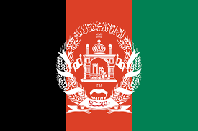
The contribution of returning refugees to reconstruction and development through skills acquired in exile is already significant and should be facilitated further through national reconstruction and development goals. UNHRC works in the country include coordinating with the authority to ensure returnees to Afghanistan take place in a safe, gradual and dignified manner. In 2018, 15,700 afghan refugees received cash grants to address their needs and 64% of 15-24-year-old refugee returnee has evolved in certified training livelihood. Afghanistan along with UNHRC has planned that 60,000 refugees will be given cash grants and 50,000 refugees will receive skill training for livelihood in 2019. More than 1.5 million Afghan refugees have gone back to Afghanistan from Pakistan since UNHCR started helping them home in March. UNHCR's winterization activities were planned in coordination with the Government of Afghanistan and emergency shelter, ensuring that vulnerable families received assistance in a timely manner. The Afghan government has encouraged a safe and dignified return of its citizens. Institutional structures, policies, and processes have been put in place to manage the return and internal displacement. In 2019 Afghanistan is working in the Guarantee of returned Afghanistan refugees, particularly women and girls, have adequate access to sanitation services, education, food and housing. Afghan looks forward to prevent undue disruption to education for returnee and IDP children, through flexible policies to recognize school certificates from countries of asylum, expanding access to education in areas of high return and displacement, mitigating security threats that contribute to children being out of school, and employing female teachers to promote the enrolment of girls in school.

