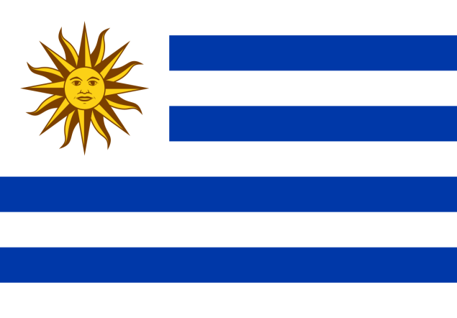
COUNTRY : Uruguay
COMMITTEE : Economic and Social Council
AGENDA : Structural barriers to economic growth and development with special emphasis on landlocked states and small island nations. DELEGATE : Saumya Mittal

A landlocked state or landlocked country is a sovereign state entirely enclosed by land, or whose only coastlines lie on closed seas. As a rule, being landlocked creates political and economic handicaps that access to the high seas avoids. Small Island Developing States (SIDS) are a group of small island countries that tend to share similar sustainable development challenges, including small but growing populations, limited resource, excessive dependence on international trade, and fragile environments. Their growth and development is also held back by high communication, energy and transportation costs, irregular international transport volumes, disproportionately expensive public administration and infrastructure due to their small size, and little to no opportunity to create economies of scale.
Uruguay is the third-best country on the continent of South America in terms of HDI, GDP growth, innovation and infrastructure. It is regarded as a high-income country by the UN. It is an upper middle income country and its economy is largely based on agriculture and the state sector. It has a mixed economic system in which there is a variety of private freedom, combined with centralized economic planning and government regulation. It is also a member of the Common Market of the South (Mercosur).
Since 2003, the Uruguayan economy has had positive economic growth rates, averaging 4,1% from 2003 to 2018. Uruguay’s economic growth has remained positive even in 2017 and 2018, in spite of recessions experienced by Argentina and Brazil, thus departing from previous patterns when growth was synchronized with that of its main neighbors.
Despite recent progress in Uruguay, several structural constraints to growth remain, in particular in the areas of infrastructure investment, integration into global value chains and education/skills performance, which may obstruct the progress towards sustainable development outcomes.
To develop the landlocked states and small island nations there is a need to transform these economies, it is essential to integrate them with the global economy, especially through trade and investments, transforming them from landlocked to land-linked. We must connect these economies with global value chains, both physically and economically. Diversification must be pursued as a long-term economic development objective, with necessary legal and institutional arrangements in place to ensure it is implemented in both good and bad times of global commodity markets. A vibrant financial sector is key to support small and medium-sized enterprises (SMEs). SMEs generate most employment opportunities, which in turn can help absorb the excess labor in low-productivity sectors.

